**Testing**

# Introduction

Here I will be testing each objective in my Raptor Hotel project. To do this I will need to create a test plan to test each objective. Then I will be running the test, detailing all the outcomes with different types of data.

# Testing plan

1. Customer should be able to log in.

**Success criteria:** There should be a form, asking customers to input their username and password. If inputted correctly it should be able to let them log in, otherwise it will display an error message.

|  |  |  |  |
| --- | --- | --- | --- |
| Test No. | Test | Type | Expected result/s |
| 1 | Enter the username “JohnSteve123” with the password “John123” | Typical | Log-in should be successful.  The user should be logged in and “frmCustMain“ should show up |
| 2 | Enter a username that is not in the database such as “Ronaldo” with the following password “John123” | invalid | The user should not be able to log in.  “Sorry, incorrect login details”  as It is not in the database |
| 3 | Enter no username and password and log in and press enter | invalid | The user should not be able to log in.  “Sorry, incorrect login details” |
| 4 | Press clear after entering the username and password | Typical | The username and password should have their text removed |
| 5 | Enter a Staff username and password such as “Jimmy123”  With the password “Jimmy123”  (staff login) | Invalid | The user should not be able to log in.  “Sorry, incorrect login details”  as It is a staff login |

1. Staff members should be able to log in.

**Success criteria:** Like the customer, in a separate form, staff members should receive a form, asking them to input their name and password. If inputted correctly it should be able to let them log in, otherwise it will display an error message.

|  |  |  |  |
| --- | --- | --- | --- |
| Test No. | Test | Type | Expected result/s |
| 6 | Enter a username “Jimmy123” with the password “Jimmy123” | Typical | Log in should be successful.  The Staff member should be logged in and “frmStaffMain“ should show up |
| 7 | Enter a username that is not in the database such as “Ronaldo” with the following password “Jimmy123” | invalid | User should not be able to log in.  “Sorry, incorrect log in details”  as It is not in the database |
| 8 | Enter no username and password and log in | invalid | User should not be able to log in.  “Sorry, incorrect log in details” |
| 9 | Press clear after entering the username and password and press enter | Typical | The username and password should have their text removed |
| 10 | Enter a customer username and password such as “JohnSteve123”  With the password “John123”  (customer login) | Invalid | User should not be able to log in.  “Sorry, incorrect log in details”  as It is a customer log in. |

1. Customers should be able to sign up.

**Success criteria:** There should be a form, asking customers to enter their details. Then ask them to create a username and password which, should be saved on the database. Then redirecting them to the login page.

|  |  |  |  |
| --- | --- | --- | --- |
| Test No. | Test | Type | Expected result/s |
| 11 | Enter all details of the customer and enter the following phone number “0987654321” . | Typical | Sign-up is successful  “successfully created an account” |
| 12 | Enter all details of the customer and enter a telephone number greater than 10 digits | Extreme | Sign-up would be unsuccessful  “Sorry please double check the details as they exceed the character/digit limit” |
| 13 | Enter no username and password and press create | invalid | The user should not be able to sign up  “Sorry, missing information” |
| 14 | Press clear after entering all customer details | Typical | The text boxes should have their text removed |
| 15 | Enter details with the following phone number with less than 10 digits | Extreme | The user should not be able to sign up.  “Sorry please double-check the details as they exceed the character/digit limit” |
| 16 | Enter details with textboxes exceeding the length of 50 | invalid | The user should not be able to sign up.  “Sorry please double-check the details as they exceed the character/digit limit” |
| 17 | Enter details with textboxes within the length of 50 | Extreme | Sign-up is successful  “successfully created an account” |
| 18 | Enter a customer with the age of 17 or below | invalid | Sign-up would be unsuccessful  “Sorry please double-check the details as they exceed the character/digit limit” |
| 19 | Enter a customer with the age of 18 or higher | Typical | Sign up successful  “Successfully created an account |

1. Staff members should be able to sign up.

**Success criteria:** Another staff member will record the other staff members' details. Then ask them to create a username and password, which should be saved on the database.

|  |  |  |  |
| --- | --- | --- | --- |
| Test No | Test | Type | Expected result/s |
| 20 | Enter all details of the staff member and enter the following phone number “0987654321” . | Typical | Sign-up is successful  “successfully created an account” |
| 21 | Enter all details of the staff member and enter a telephone number greater than 10 digits | Extreme | Sign-up would be unsuccessful  “Sorry please double check the details as they exceed the character/digit limit” |
| 22 | Enter no username and password and press create | invalid | User should not be able to sign up  “Sorry, missing information” |
| 23 | Press clear after entering all staff members' details | Typical | The text boxes should have their text removed |
| 24 | Enter details with the following phone number with less than 10 digits | Extreme | The user should not be able to sign up.  “Sorry please double-check the details as they exceed the character/digit limit” |
| 25 | Enter details with textboxes exceeding the length of 50 | invalid | The user should not be able to sign up.  “Sorry please double-check the details as they exceed the character/digit limit” |
| 26 | Enter details with textboxes within the length of 50 | Extreme | Sign-up is successful  “successfully created an account” |
| 27 | Enter a staff member with the age of 17 or below | invalid | Sign-up would be unsuccessful  “Sorry please double-check the details as they exceed the character/digit limit” |
| 28 | Enter a staff member with the age of 18 or higher | invalid | Sign-up would be unsuccessful  “Sorry please double-check the details as they exceed the character/digit limit” |

1. Should authorize staff to add, edit, delete, and find customers.

**Success criteria:** There should be a search function where you can search for customers with either customer name or customer ID, once the customer they should be able to edit, add, and delete that customer's information.

|  |  |  |  |
| --- | --- | --- | --- |
| Test No | Test | Type | Expected result/s |
| 29 | Enter all details of the customer and enter the following phone number “0987654321” . | Typical | Sign-up is successful  “successfully created an account” |
| 30 | Enter all details of the customer and enter a telephone number greater than 10 digits | Extreme | Sign-up would be unsuccessful  “Sorry please double check the details as they exceed the character/digit limit” |
| 31 | Enter no username and password and press “save” | invalid | User should not be able to sign up  “Sorry, missing information” |
| 32 | Press clear after entering all customer details | Typical | The text boxes should have their text removed |
| 33 | Enter details with the following phone number with less than 10 digits | Extreme | The user should not be able to sign up.  “Sorry please double-check the details as they exceed the character/digit limit” |
| 34 | Enter details with textboxes exceeding the length of 50 | invalid | The user should not be able to sign up.  “Sorry please double-check the details as they exceed the character/digit limit” |
| 35 | Enter details with textboxes within the length of 50 | Extreme | Sign-up is successful  “successfully created an account” |
| 36 | Enter a customer with the age of 17 or below | invalid | Sign-up would be unsuccessful  “Sorry please double-check the details as they exceed the character/digit limit” |
| 37 | Enter a customer with the age of 18 or higher | invalid | Sign-up would be unsuccessful  “Sorry please double-check the details as they exceed the character/digit limit” |
| 38 | With the customer's details, press the button “delete” | typical | “Are you sure you want to delete this customer”  If yes, then delete customer |
| 39 | Press search when there is no customer surname or ID when searching | typical | Nothing will happen |
| 40 | Press search when customer ID that exist is pressed | typical | Customers data should appear |
| 41 | Press search when customer surname that exist is entered | typical | Customers data should appear |
| 42 | Press search when customer surname that dosent exist is entered | invalid | “could not find customer with that surname” |
| 43 | Press search when customer ID that dosent exist is entered | invalid | “Could not find customer with that username” |
| 44 | Press save when no changes are made to a customer | typical | “Sorry please double-check the details as they exceed the character/digit limit” |

1. The system should display a brief description of the room with what the room comes with, for example, a coffee machine.

**Success criteria:** Staff members and customers should be able to see a brief description of the room and what it comes with. This also gives a brief idea of what you are paying for. Staff members should be able to add and edit the description.

|  |  |  |  |
| --- | --- | --- | --- |
| Test No | Test | Type | Expected result/s |
| 45 | Add a description to any room that exist | Typical | It would add the description to the database  “Successfully added the room” |
| 46 | Update a description to any room that exist | typical | It would update the description  “Successfully updated the room |
| 47 | Add a description with no room number | invalid | Should not add the description  “Sorry, missing information” |

1. Customers should be able to edit saved information.

**Success criteria:** Customers should be able to edit saved information, for example, if a customer wants to change their name, they could do so in the form.

|  |  |  |  |
| --- | --- | --- | --- |
| Test No. | Test | Type | Expected result/s |
| 48 | Enter all details of the customer and enter the following phone number “0987654321” . | Typical | Sign-up is successful  “Your information has been updated” |
| 49 | Enter all details of the customer and enter a telephone number greater than 10 digits | Extreme | Sign-up would be unsuccessful  “Sorry please double check the details as they exceed the character/digit limit” |
| 50 | Enter no username and password and press create | invalid | User should not be able to sign up  “Sorry, missing information” |
| 51 | Press clear after entering all customer details | Typical | The text boxes should have their text removed |
| 52 | Enter details with the following phone number with less than 10 digits | Extreme | The user should not be able to sign up.  “Sorry please double-check the details as they exceed the character/digit limit” |
| 53 | Enter details with textboxes exceeding the length of 50 | invalid | The user should not be able to sign up.  “Sorry please double-check the details as they exceed the character/digit limit” |
| 54 | Enter details with textboxes within the length of 50 | Extreme | Sign-up is successful  “Your information has been updated” |
| 55 | Enter a customer with the age of 17 or below | invalid | Sign-up would be unsuccessful  “Sorry please double-check the details as they exceed the character/digit limit” |
| 56 | Enter a customer with the age of 18 or higher | invalid | Sign-up would be unsuccessful  “Your information has been updated” |

1. Customers should be able to see previous bookings.

**Success criteria:**  Customers should be able to select any booking that they customer made and display all the information about that booking.

|  |  |  |  |
| --- | --- | --- | --- |
| Test No | Test | Type | Expected result/s |
| 57 | With a user that has bookings  Click on a booking in the list box | Typical | Should display all booking details |
| 58 | With a user that has multiple bookings  Switch between different bookings and see if they change or not. | typical | Should change booking details depending on booking ID |
| 59 | Try using the form with a user with no bookings | invalid | Should not do anything. Just blank textboxes etc.. |
| 60 | Try changing the booking details. Do they change? | Invalid | Should not save the changes. |

1. Staff members should be able to log out.

**Success criteria:** Like the customer, once the staff member has finished what they wanted to do, the staff members should be able to log out or exit the system.

|  |  |  |  |
| --- | --- | --- | --- |
| Test No | Test | Type | Expected result/s |
| 61 | Try logging out by pressing the log-out button | Typical | Should log out the user and redirect to login form |

1. Should be able to authorize staff to change the availability of the room.

**Success criteria:** Staff members should be able to change the availability of the room, for example, if the room is “occupied” and that person is no longer staying in staff members can change the “occupied” into “available”.

|  |  |  |  |
| --- | --- | --- | --- |
| Test No | Test | Type | Expected result/s |
| 62 | Try changing the status of the room from occupied to available to room 2  And save | Typical | Should save the changes and not display in the booking form |
| 63 | Try changing the status of the room from available to occupied  And save | Typical | Should save the changes and display them in the booking form |
| 64 | Try changing the status of the room without saving | invalid | Should not save changes and should/ should display depending on the status |

1. There should be no collision.

**Success criteria:** Should display the availability of the room, for example, if the room is in use, state that the room is “occupied”.

|  |  |  |  |
| --- | --- | --- | --- |
| Test No | Test | Type | Expected result/s |
| 65 | Test if there is an “occupied” room in the form booking | Typical | It should only display rooms that are available |
| 66 | Try to book a room number 2 (Available) for 4 nights from 02/02/2024 to 06/02/2024. | Extreme | Should allow the user to book the room |
| 67 | Try to book a room with no details entered | invalid | Should do nothing  “Missing information” |
| 68 | Test if the total payment has the correct figures | Typical | Should display right figure |
| 69 | Try to book a room that is occupied | Invalid | Should not make the booking  “Sorry that room is occupied” |

1. Customers should be able to log out.

**Success criteria:** Once the customer has finished what they wanted to do, the customers should be able to log out or exit the system.

|  |  |  |  |
| --- | --- | --- | --- |
| Test No | Test | Type | Expected result/s |
| 70 | Try logging out by pressing the log-out button | Typical | Should log out the user and redirect to login form |

1. The project should connect to a database.

**Success criteria:** The project connects to Access (the database I am using) and displays the right data.

|  |  |  |  |
| --- | --- | --- | --- |
| Test No | Test | Type | Expected result/s |
| 71 | Try any function that requires to connect to the database | Typical | The function should work as intended. |

1. Should authorize staff members to make changes to rooms.

**Success criteria:** Enable Staff members to make changes to the room eg bed type.

|  |  |  |  |
| --- | --- | --- | --- |
| Test No | Test | Type | Expected result/s |
| 72 | Update room “5” and change its availability and press the update button | Typical | Should be able to update  "Successfully updated” |
| 73 | Try to update the room description and room content of room number “10” to nothing | Extreme | Should be able to update  “Successfully updated” |
| 74 | Delete room number “10” | Typical | “Are you sure you want to delete “  If yes then delete |
| 75 | Use the clear button when you choose a room | Typical | Should clear all boxes but not save. |
| 76 | Update room “5” and change its availability and not press the update button | invalid | Should not save details |
| 77 | Use the update button when everything is blank | invalid | Should do nothing |

1. There should be pictures of the room in the system.

**Success criteria:** Staff members and customers should be able to see a picture of the room, with accessories, and decoration. This is to get a brief idea of what you are paying for. Staff members should be able to add and edit the picture/s.

|  |  |  |  |
| --- | --- | --- | --- |
| Test No | Test | Type | Expected result/s |
| 78 | Should store the image in base 64 | Typical | “successfully added to database” |
| 79 | Should display the image in form room 1 | typical | Displays the correct image for the room chosen |
| 80 | Add an image to room number 3 | invalid | Should add the image to room number 3 |

The system should be able to work and fully function. / WHOLE SYSTEM

**Success criteria:** The system should be able to make a booking and should be displayed in the database.

Actual Test Runs

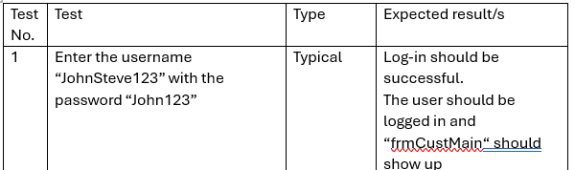

Before

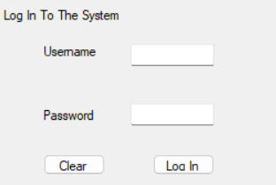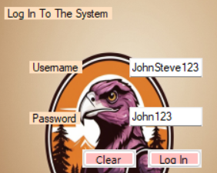

After

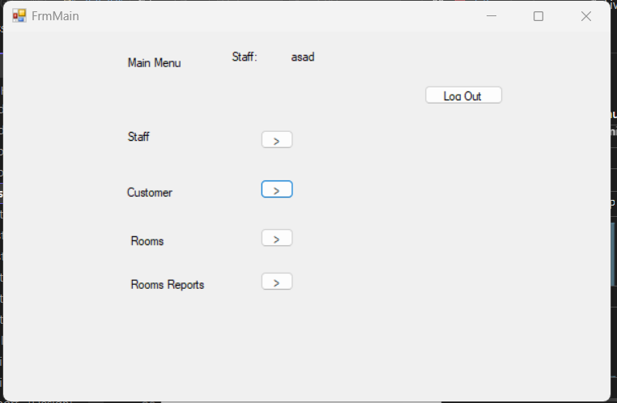

Test passed as the formCustMain is shown.

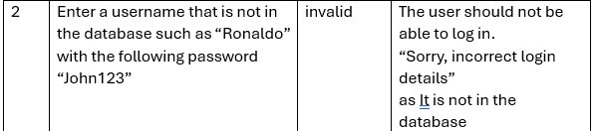

Before:

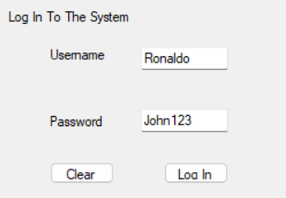

After:

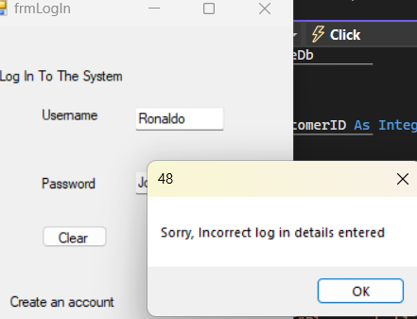

Test passed

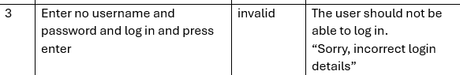

Before:

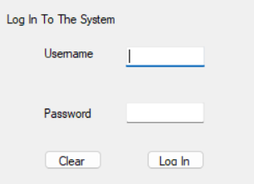

After

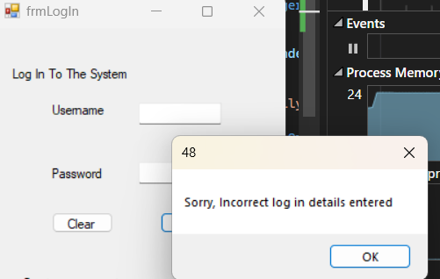

Test passed

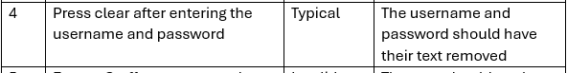

Before

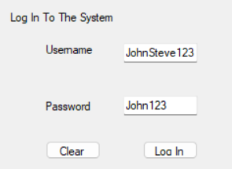

After

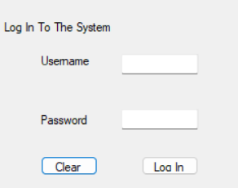

**test passed**

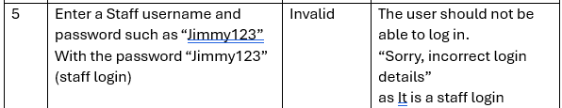

Before

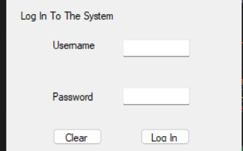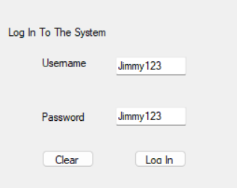

After

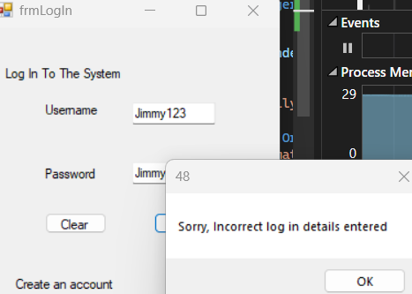

**Test** **passed**

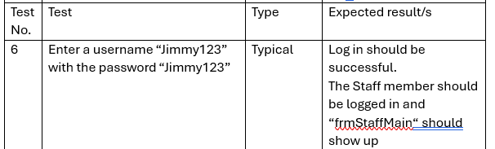

Before

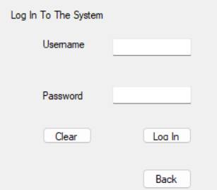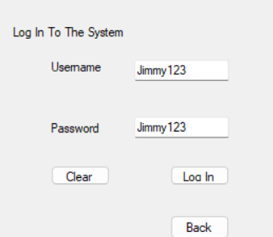

After



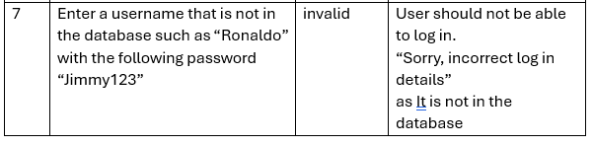

Before

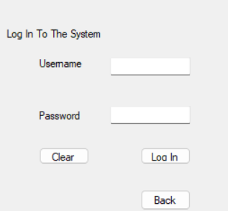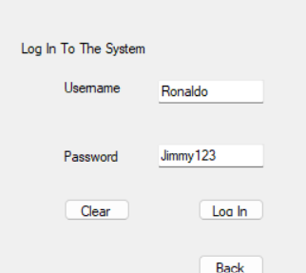

After

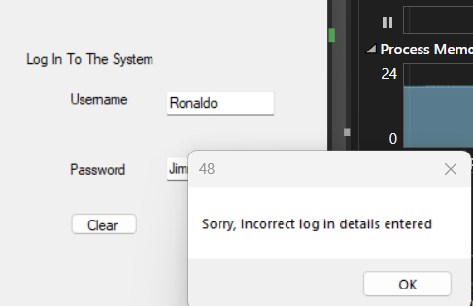

Tess passed

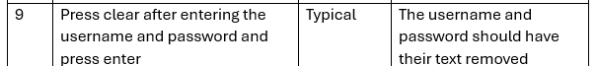

before

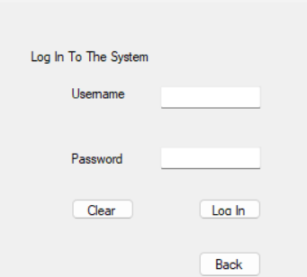

After

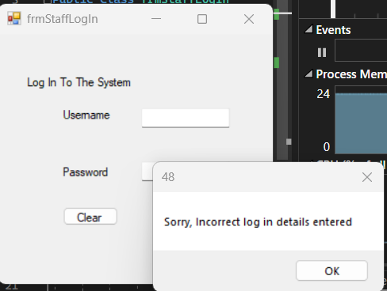

Tess passed

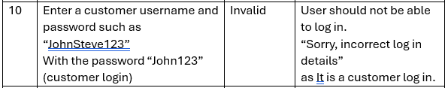

Before

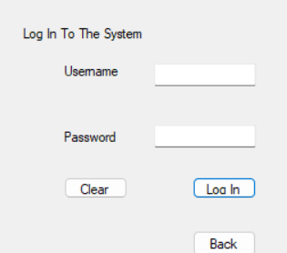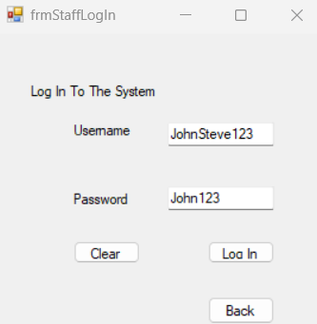

After

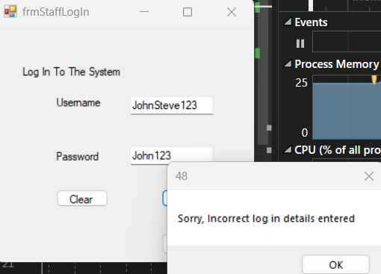

Tess passed

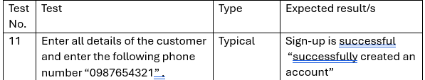

Before

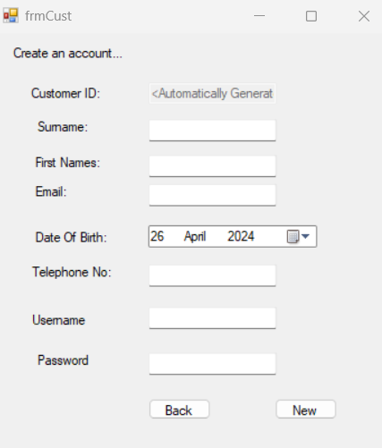

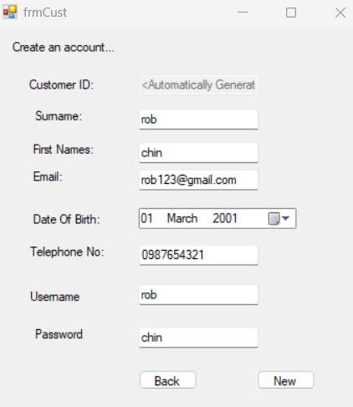

After

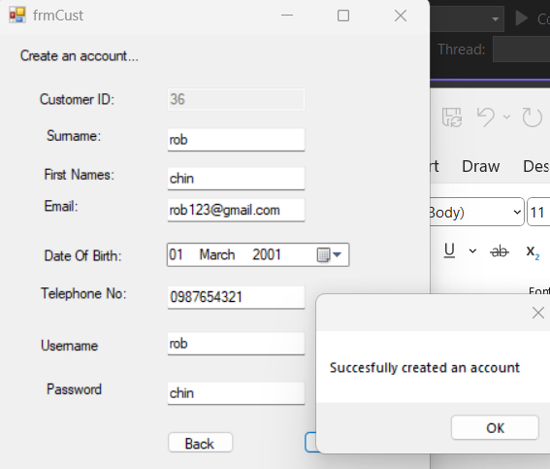

**Test passed**

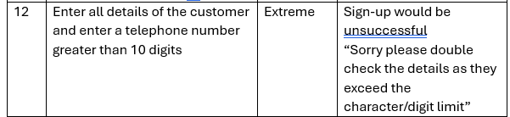

Before



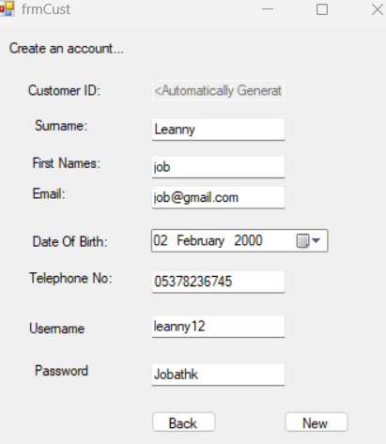

After

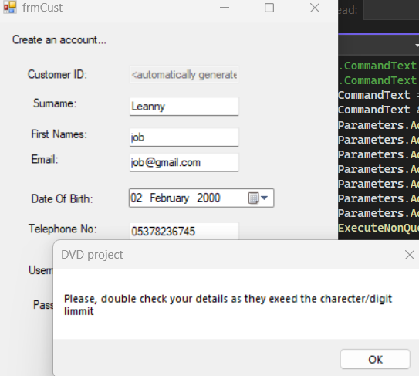

Test passed

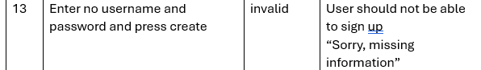’

Before



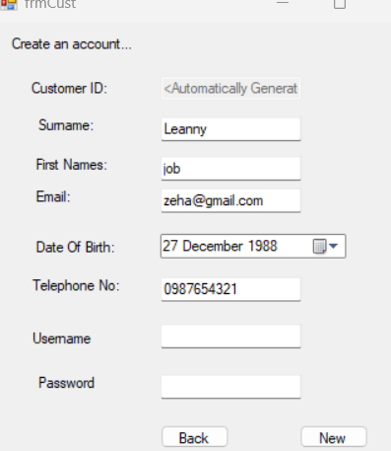

After

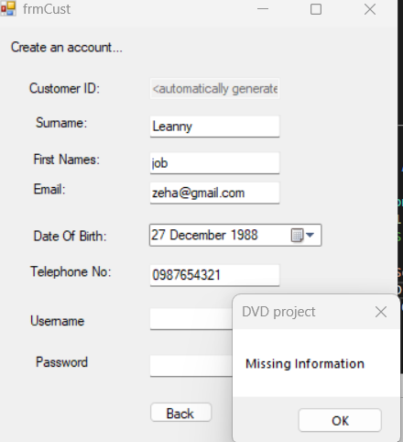

Test passed

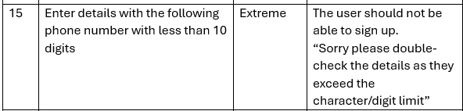

Before



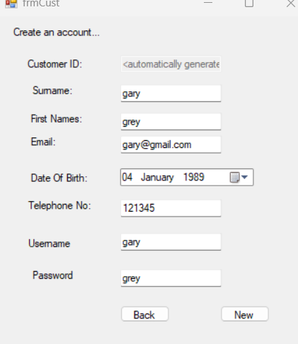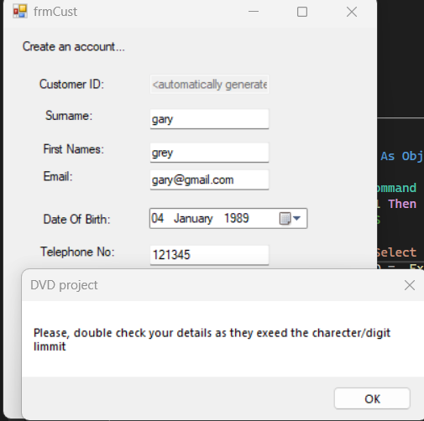

test passed

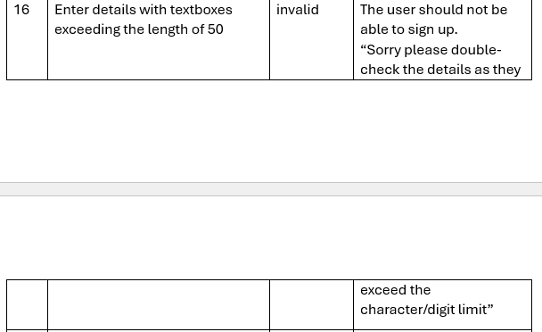

Before



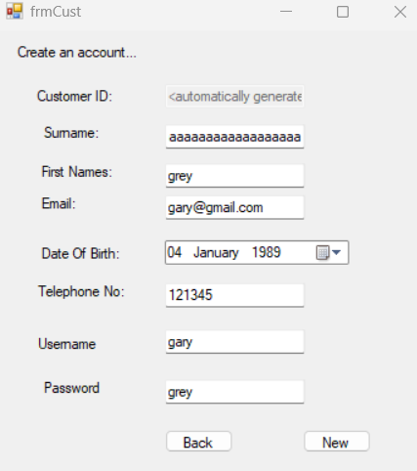

After

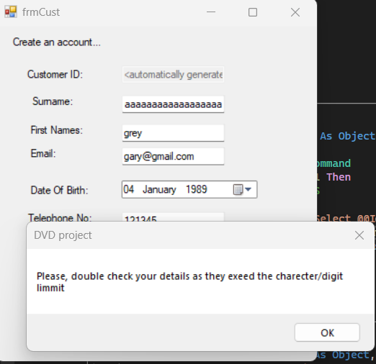

Test passed

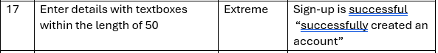

Before



After

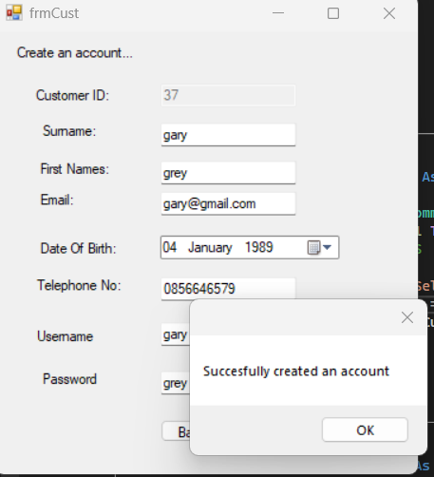

Test passed

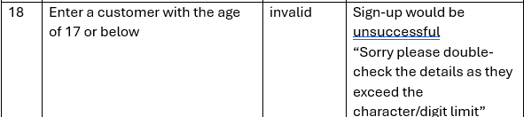

Before

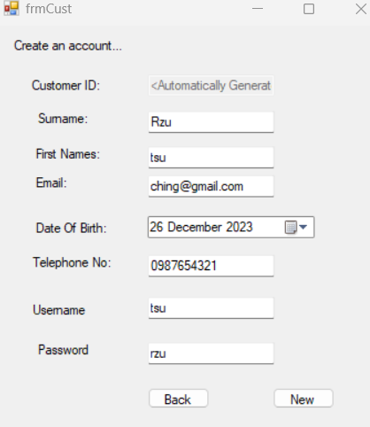

After

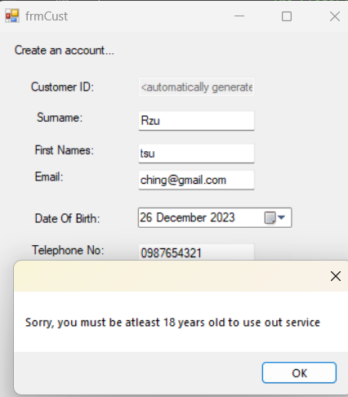

Test passed

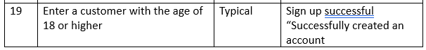

Before

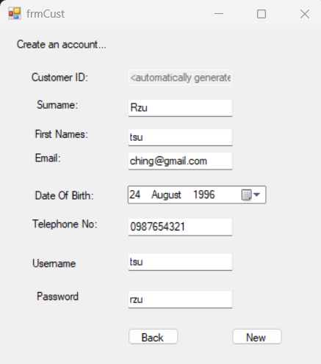

After

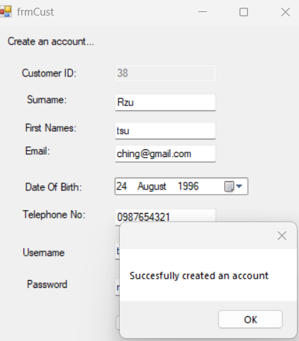

Test passed

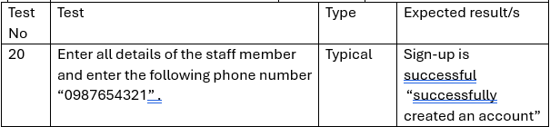

Before

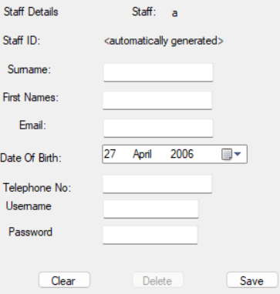 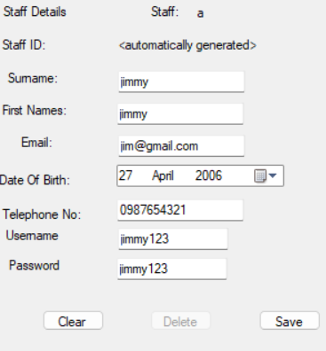

After

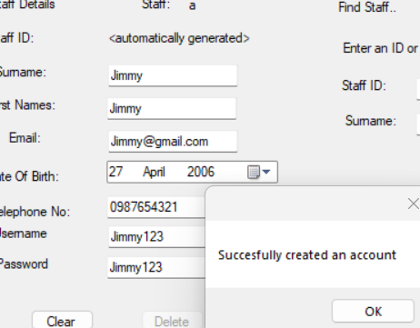

Test passed

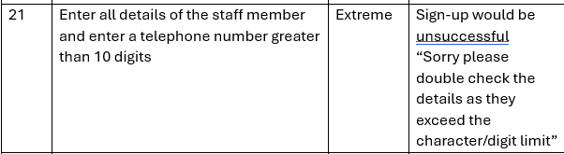

Before



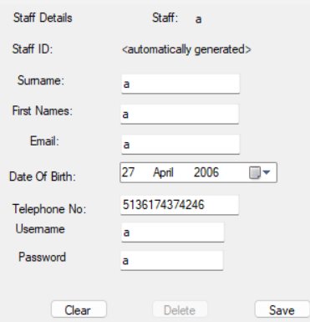

After

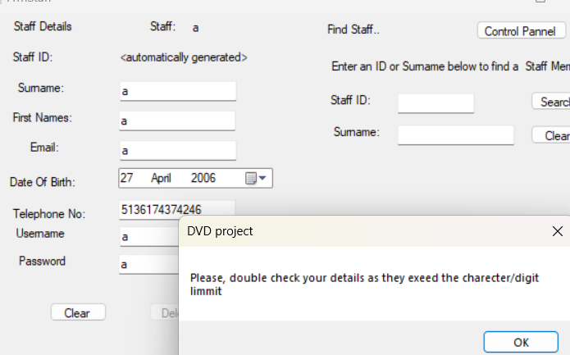

Test passed

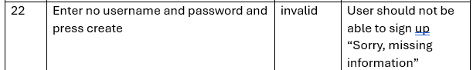

Before



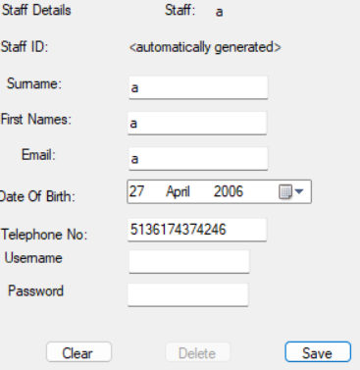

After

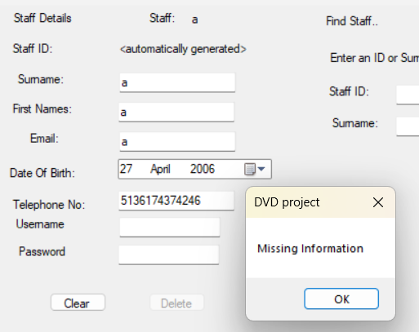

Test passed

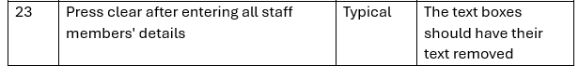

Before

 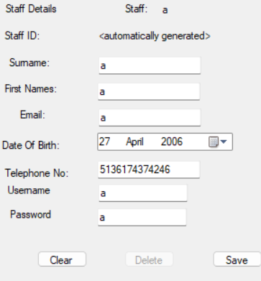

After

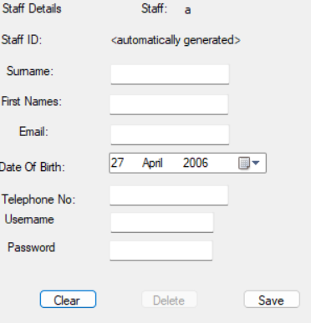

Test passed

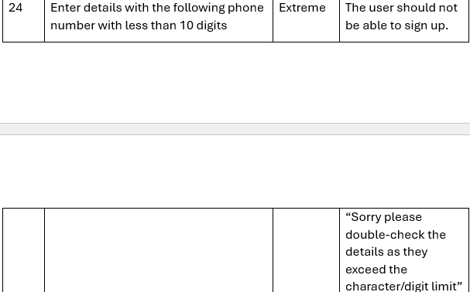

Before

 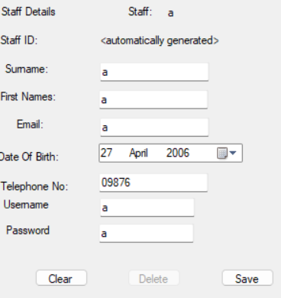

After

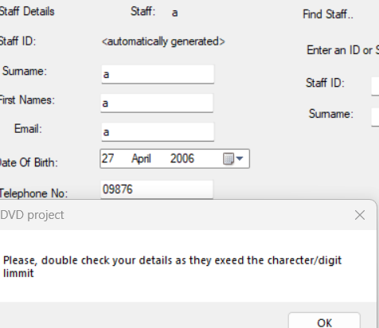

Test passed

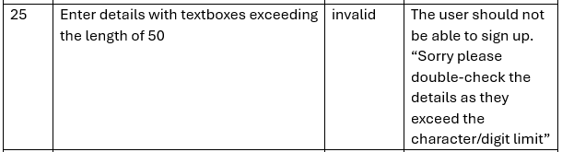

Before

 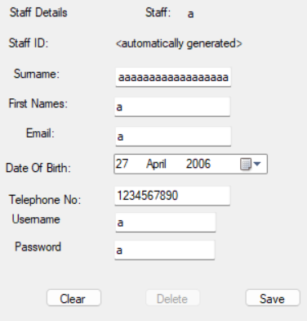

After

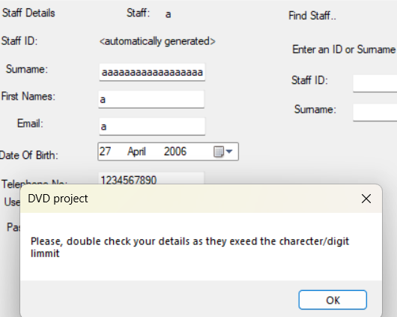

Test passed

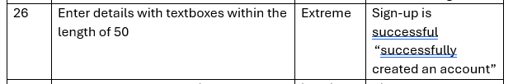

Before

 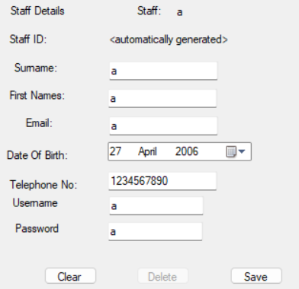

After

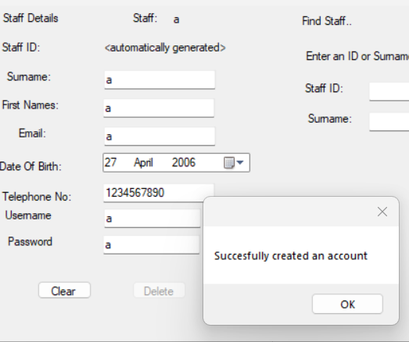

Test passed

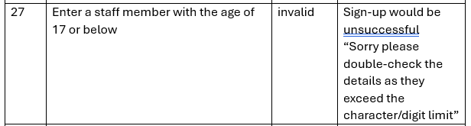

Before

 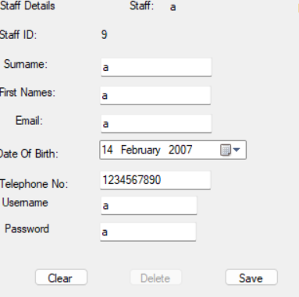

After

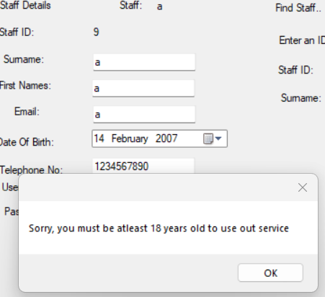

Test passed

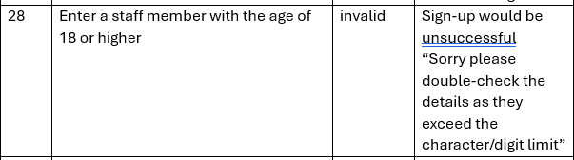

Before



After



Test passed

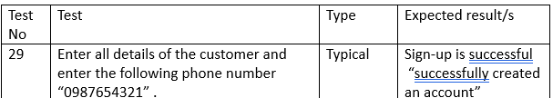

Before

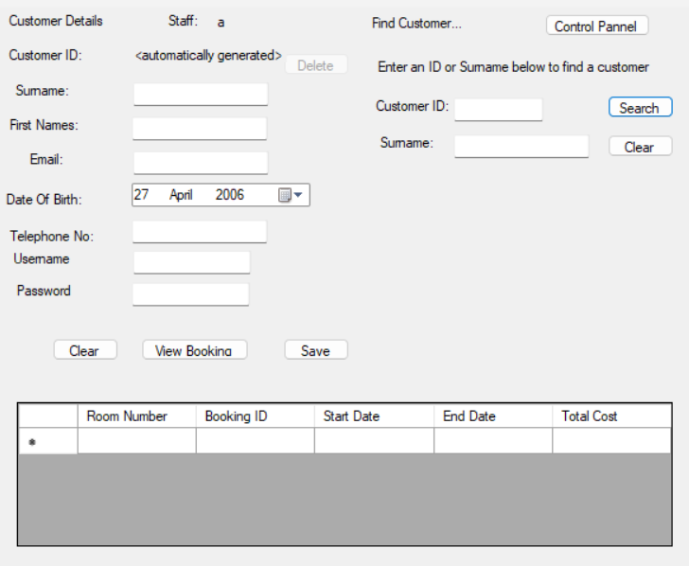

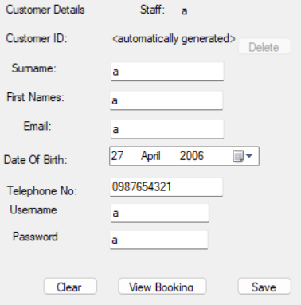

After

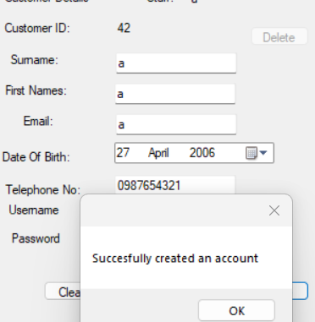

Test passed

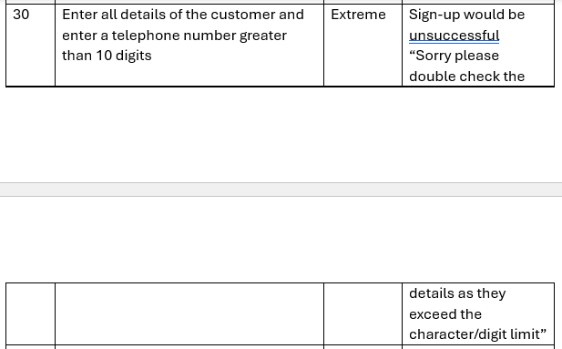

Before



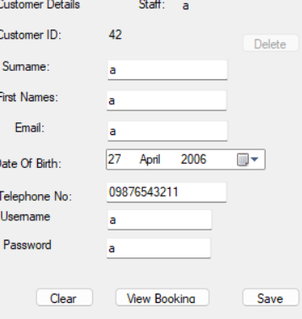

After

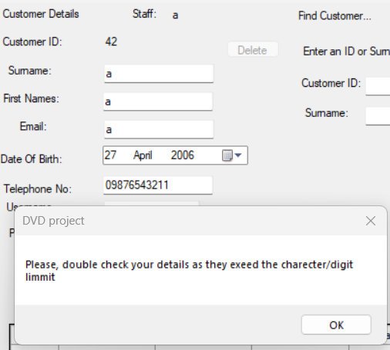

Test passed

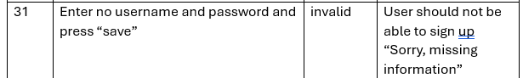

Before



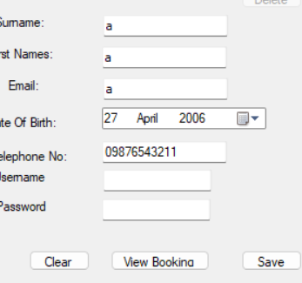

After

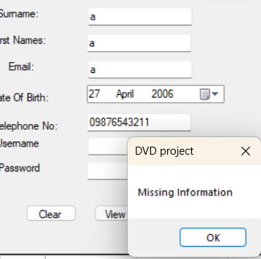

Test passed

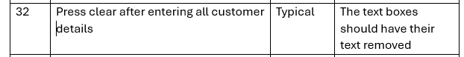

Before



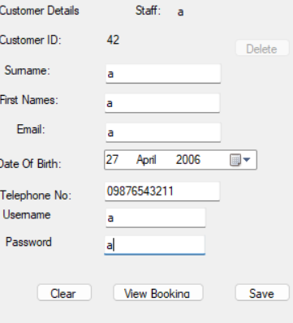

After

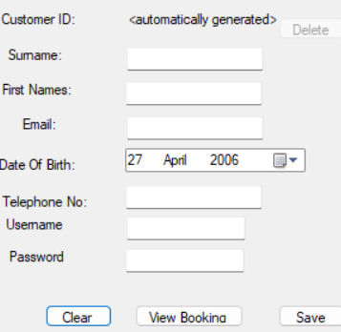

Test passed

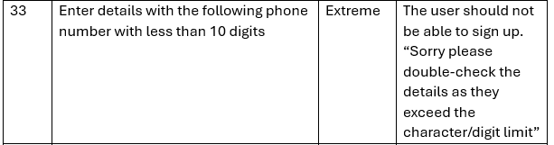

Before



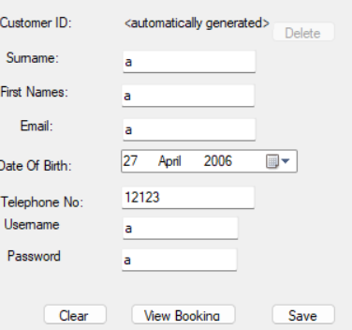

After

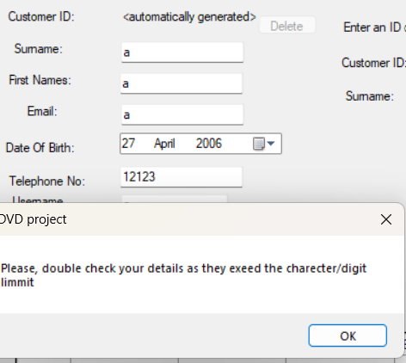

Test passed

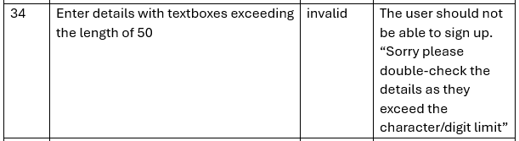

Before



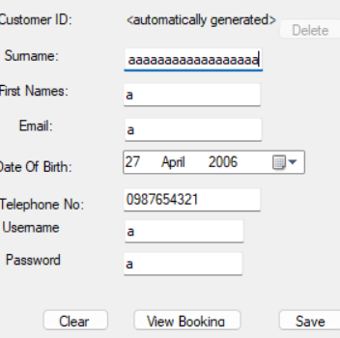

After

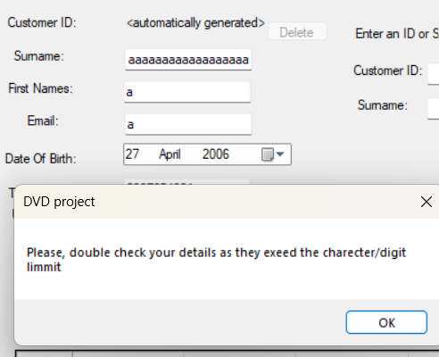

Test passed

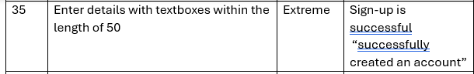

Before



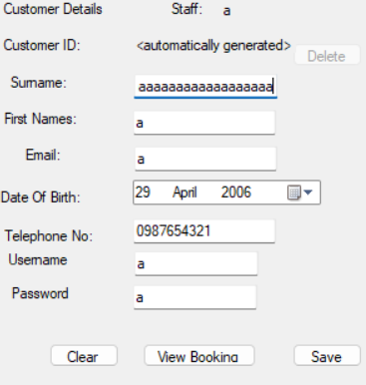

After

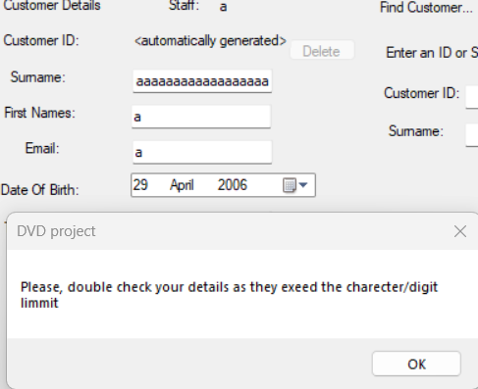

Test passed

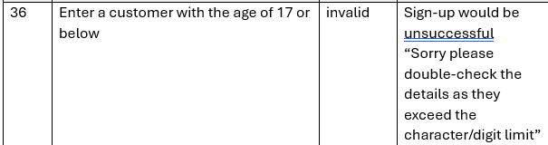

Before



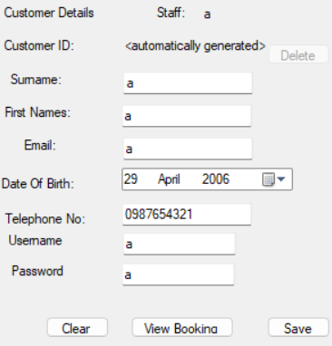

After

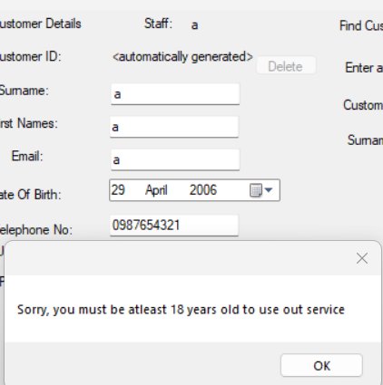

Test passed

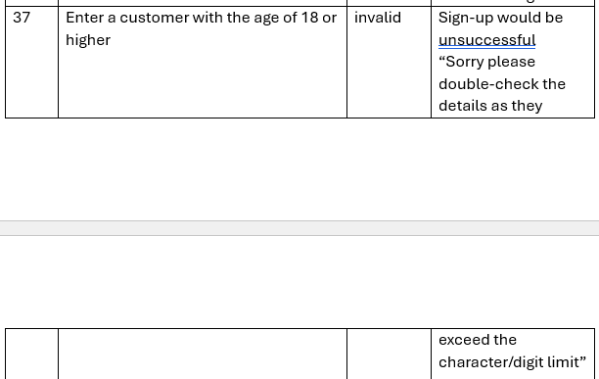

Before



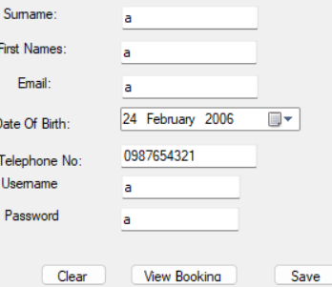

After

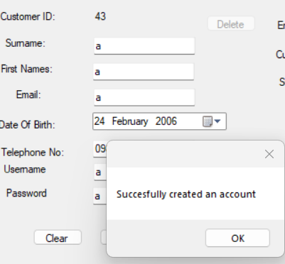

Test passed

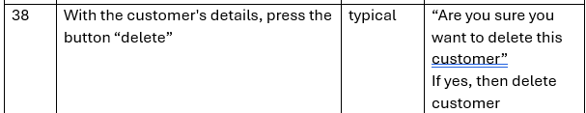

Before

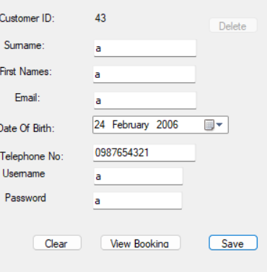

After

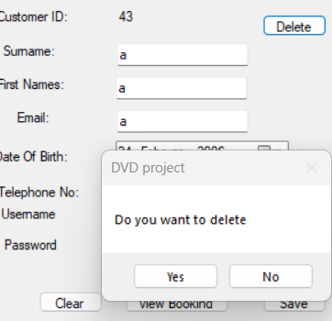



The user has been deleted

Test passed

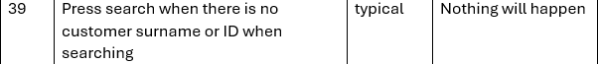

Before



After

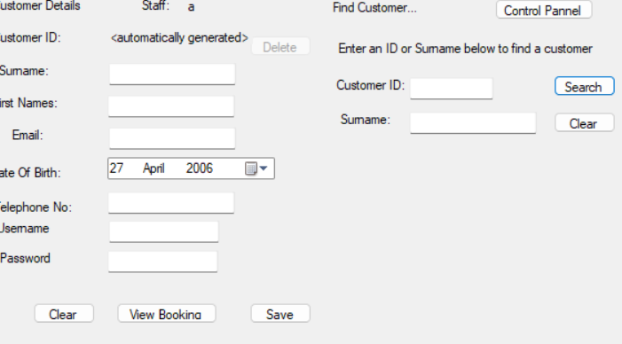

Test passed



Before



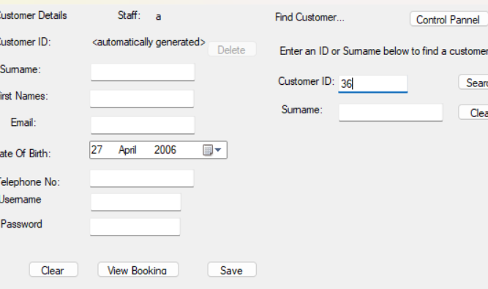

After

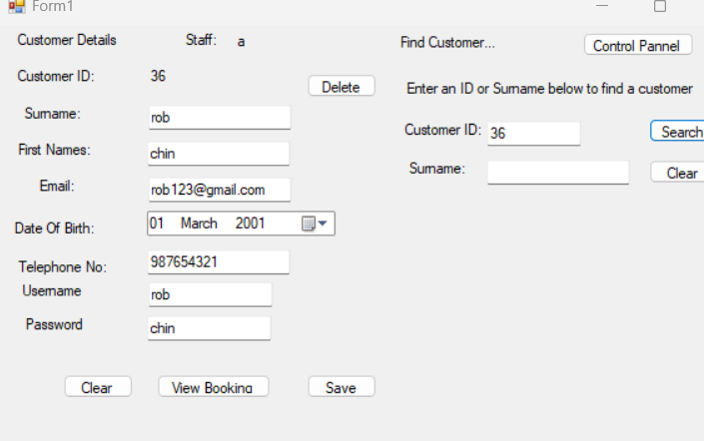

Test passed



Before



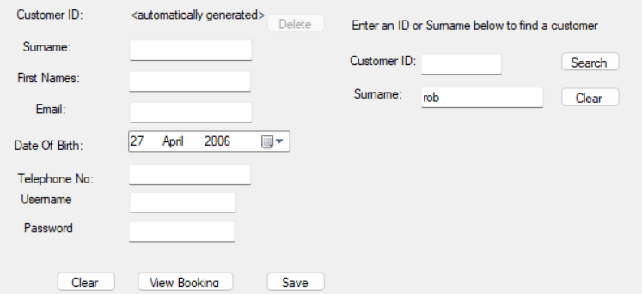

After

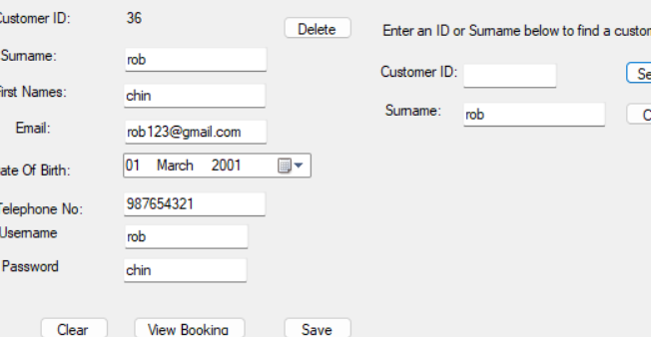

Test passed

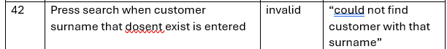

Before



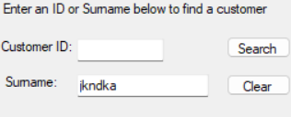

After

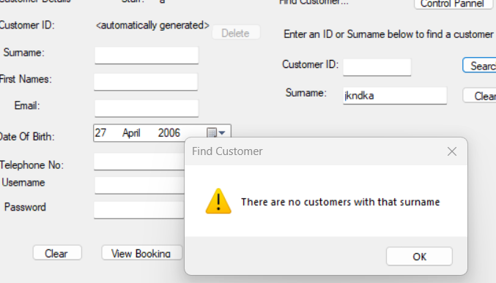

Test passed

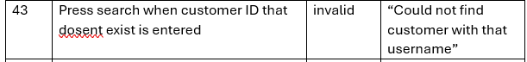

Before



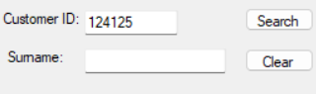

After

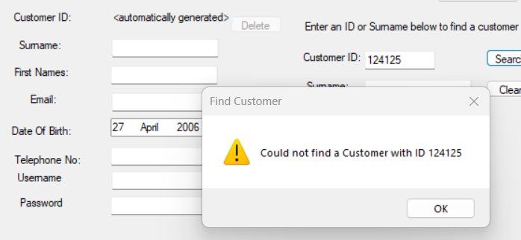

Test passed

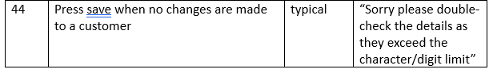

Before



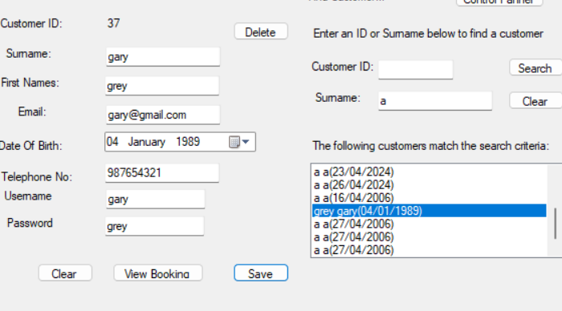

After

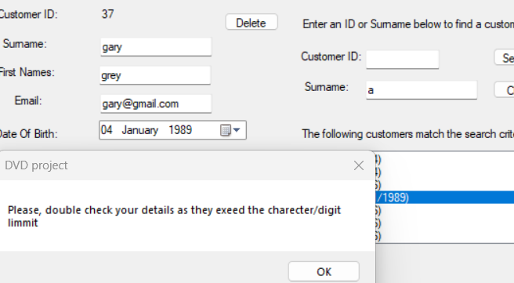

Test passed

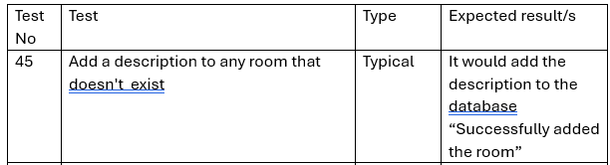

Before

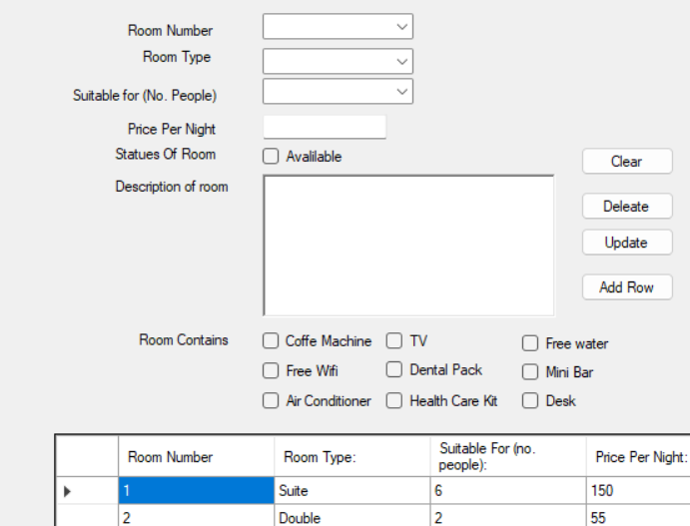

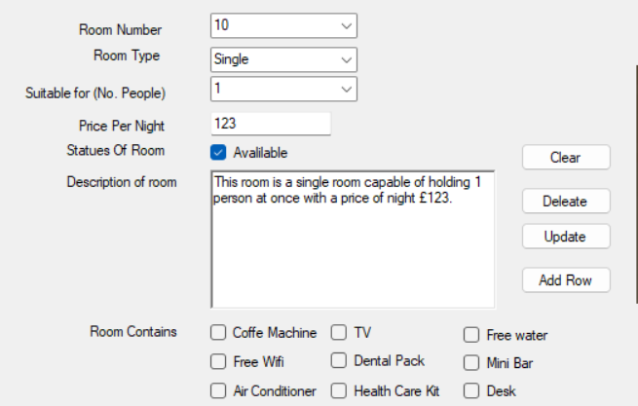

After

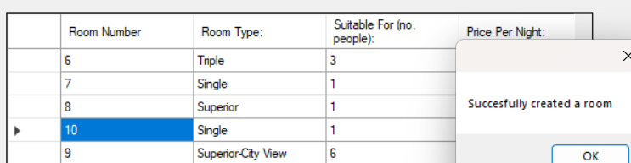

Test passed

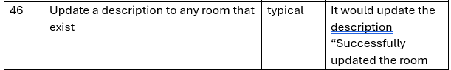

Before



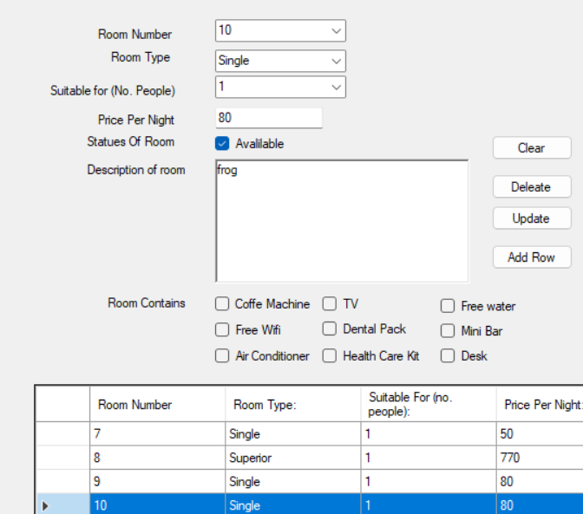

After

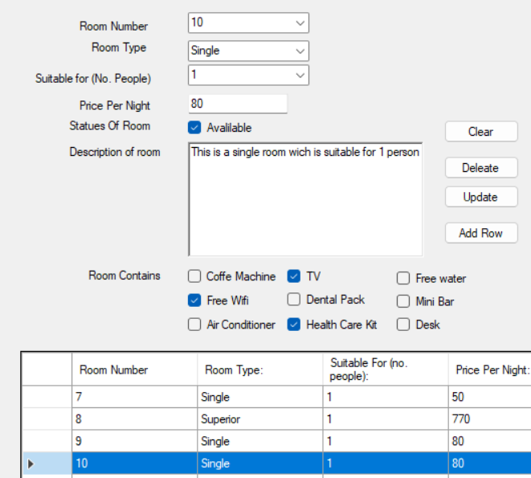

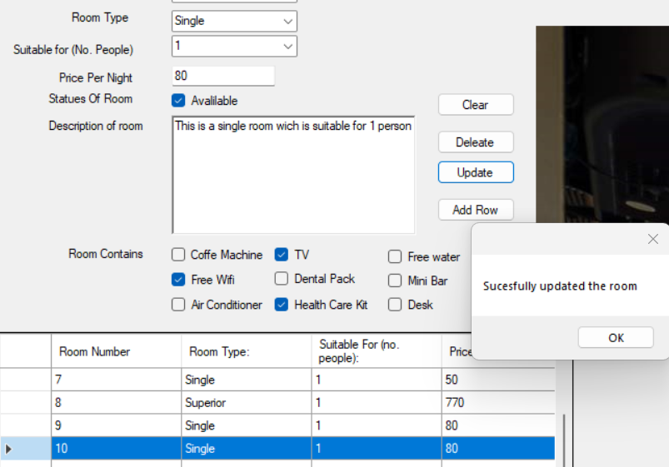

Test passed

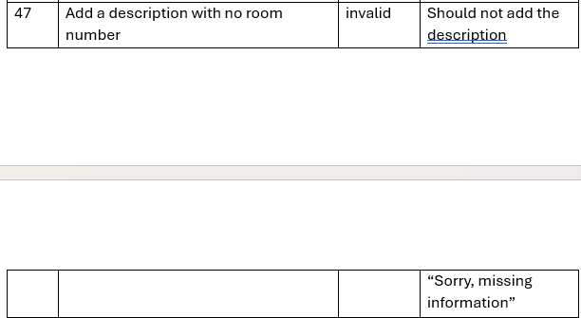

Before

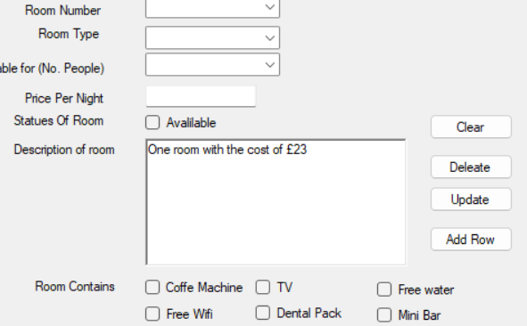

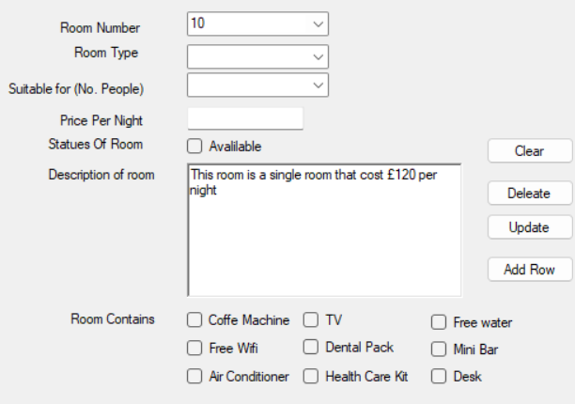

After

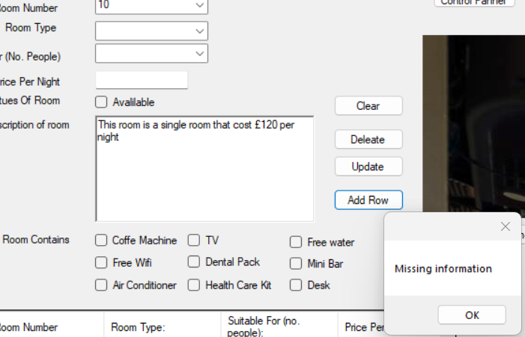

Test passed

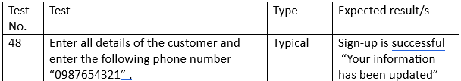

Before

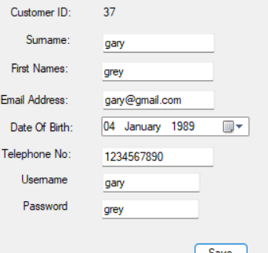 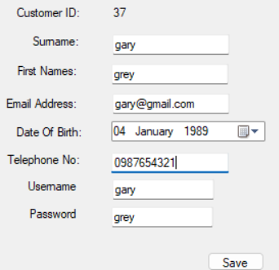

After

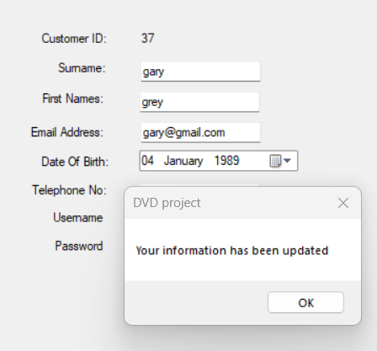

Test passed

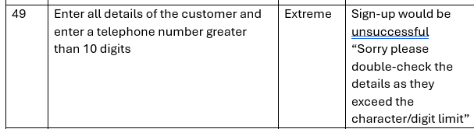

Before

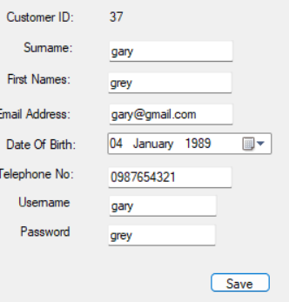 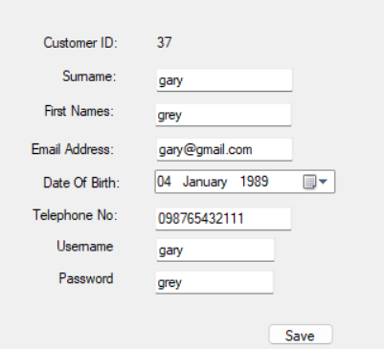

After

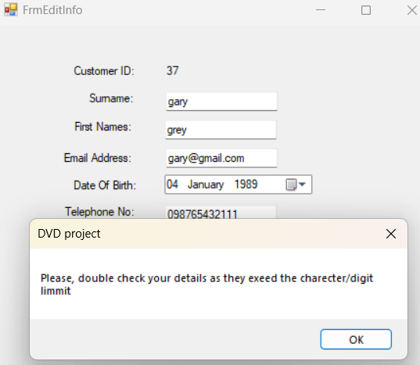

Test passed

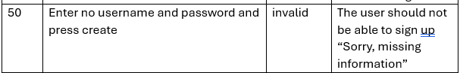

Before

 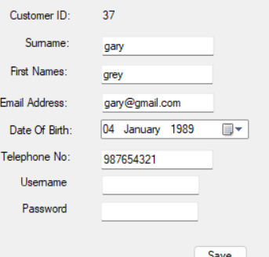

After

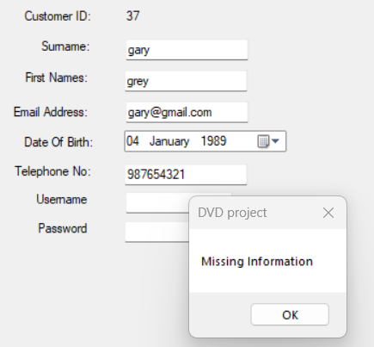

Test passed

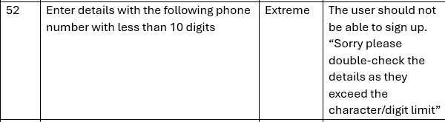

Before

 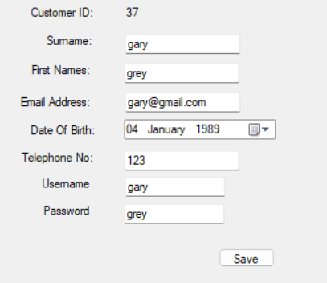

After

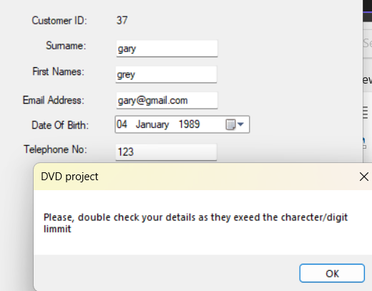

Test passed

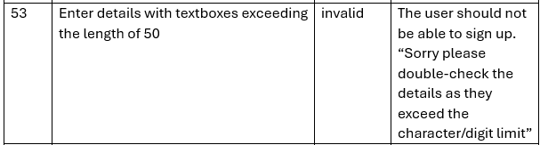

Before

 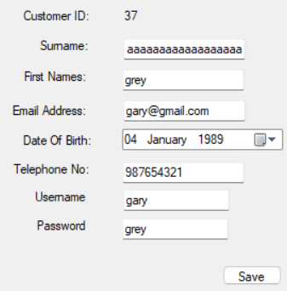

After

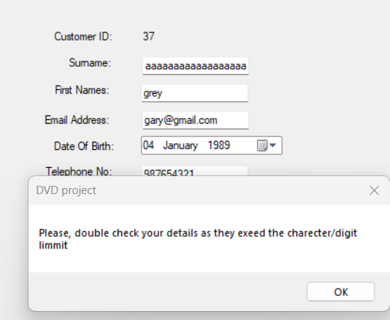

Test passed

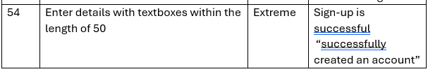

Before

 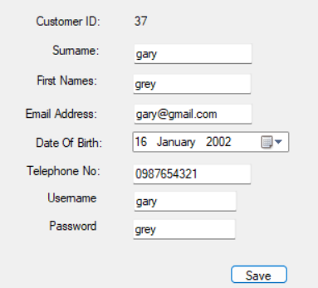

After

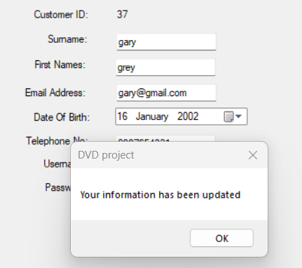

Test passed

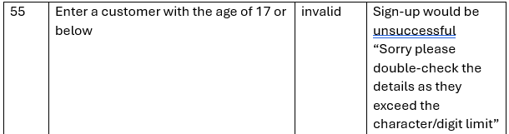

Before

 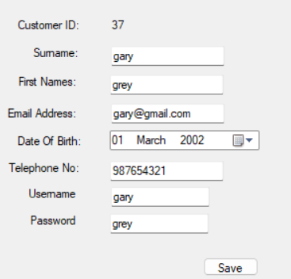

After

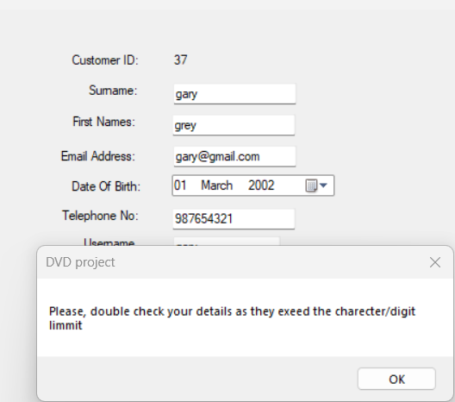

Test passed

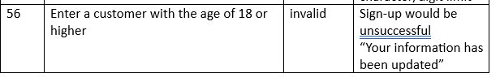

Before

 

After



Test passed

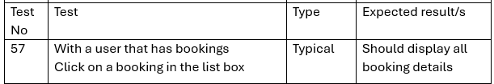

Before

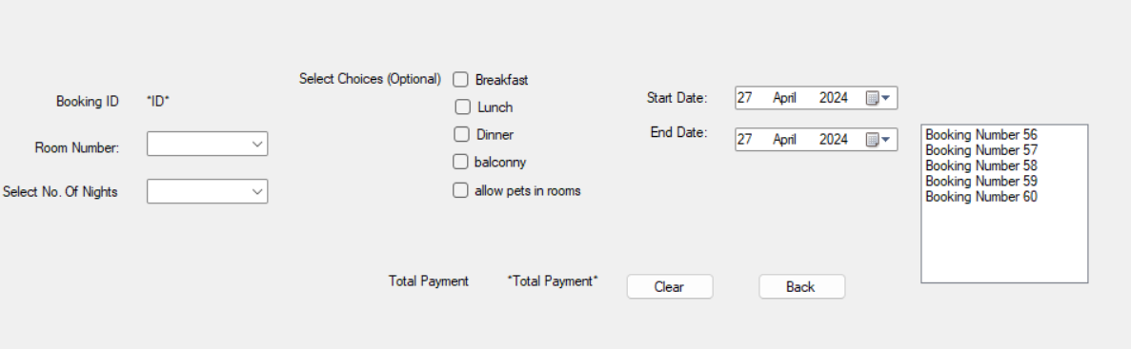

After

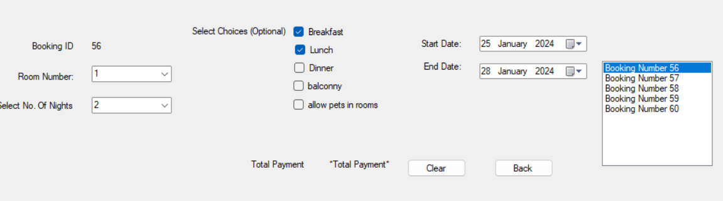

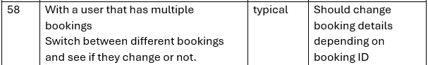

Before





After

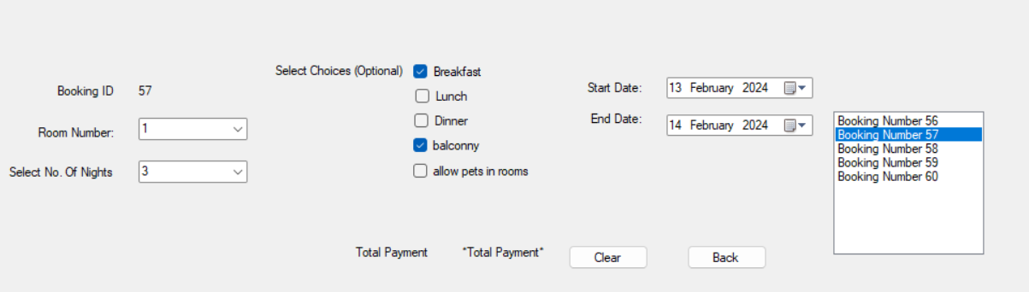

Yes the details change between the bookings

Test passed

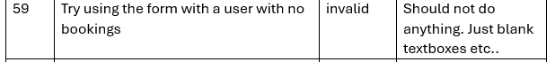

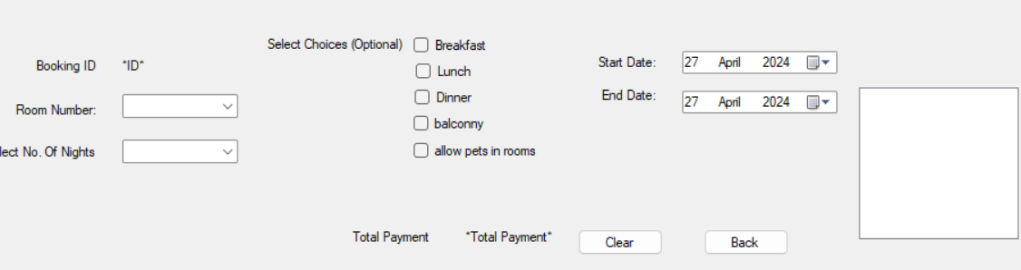

Yes the works still work therefore test passed

Test passed



Before





After

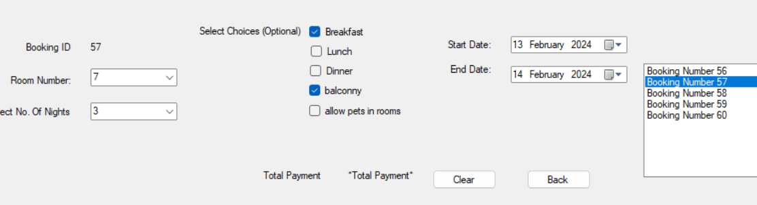



No, the booking details don’t change therefore test passed

Test passed

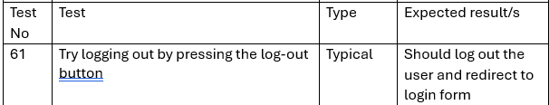

Before

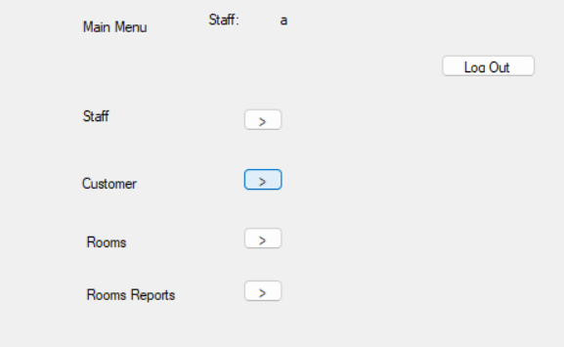

After

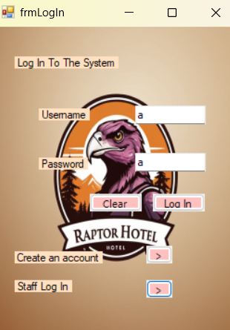

Test passed

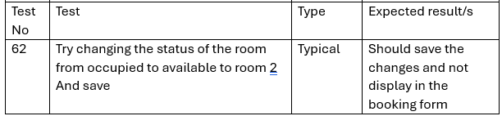

Before

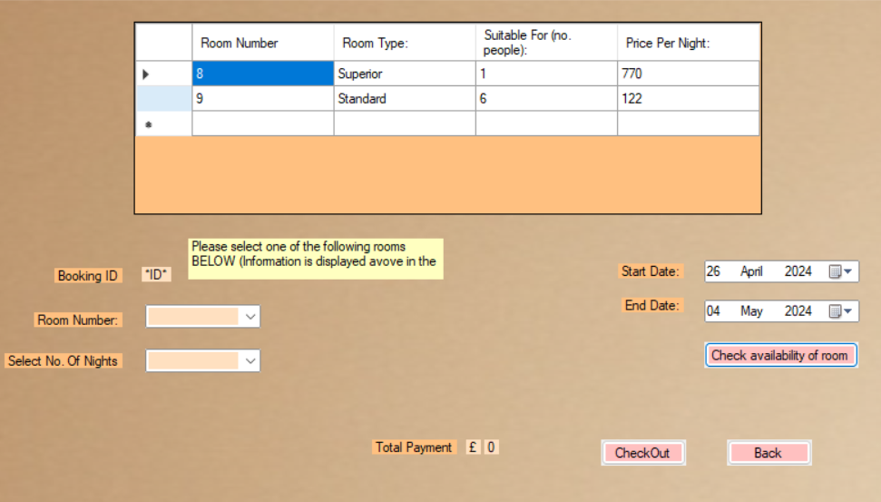

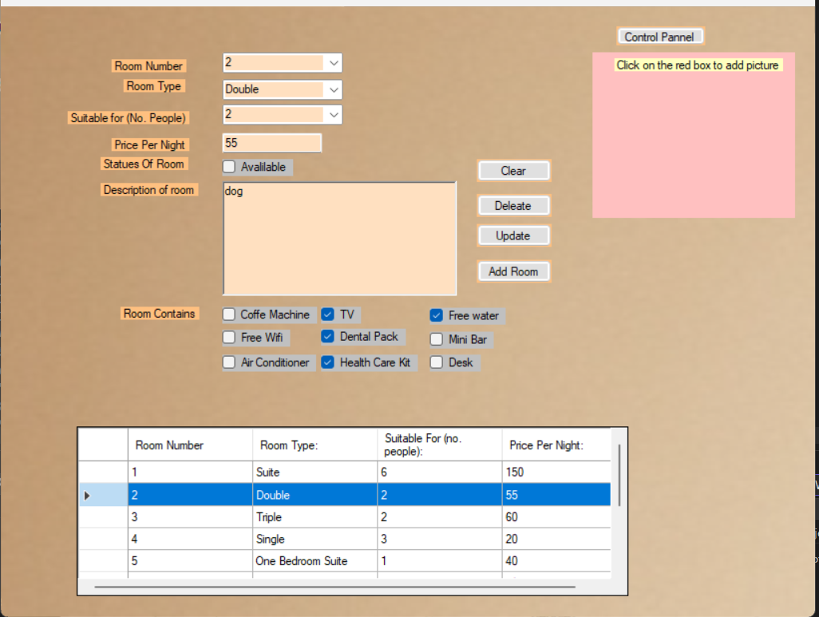

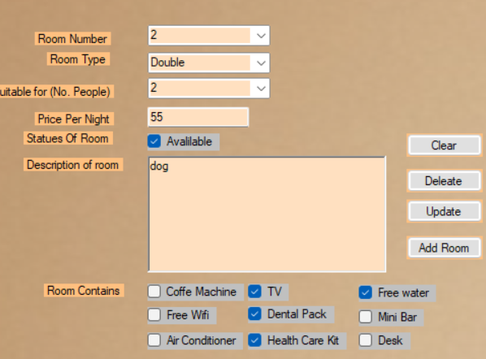

After

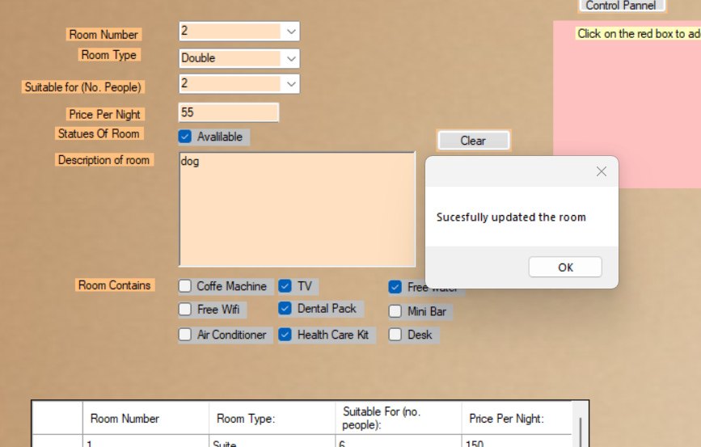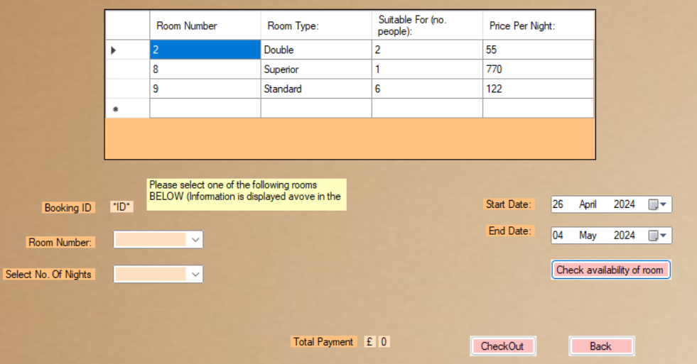

Test passed

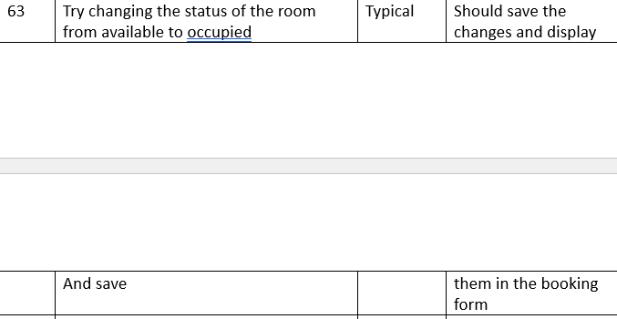

Before







After

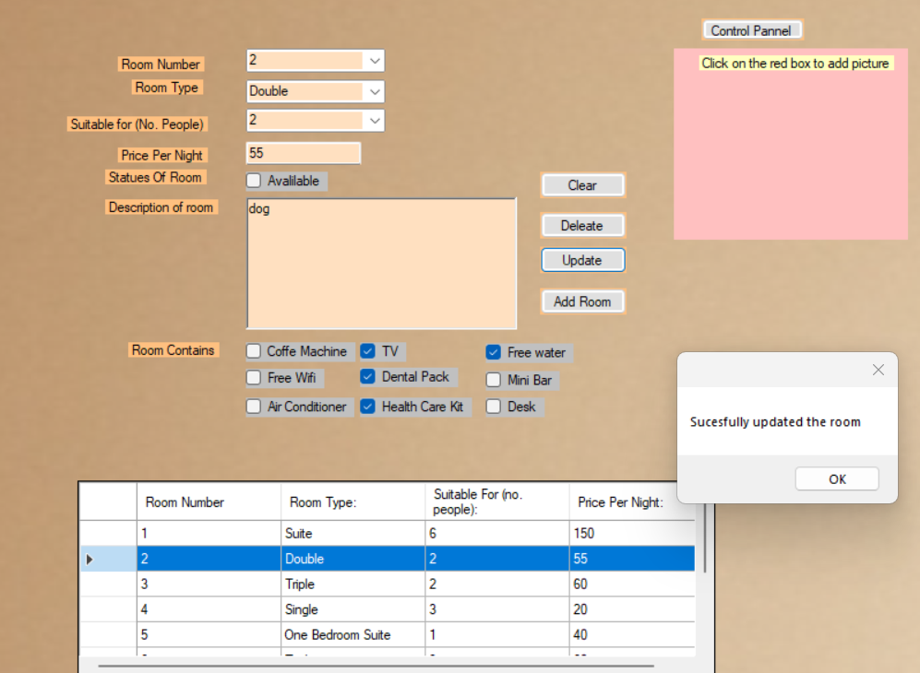



Test passed

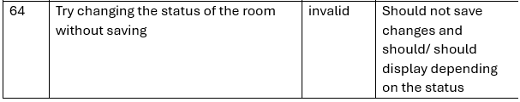

Before

After



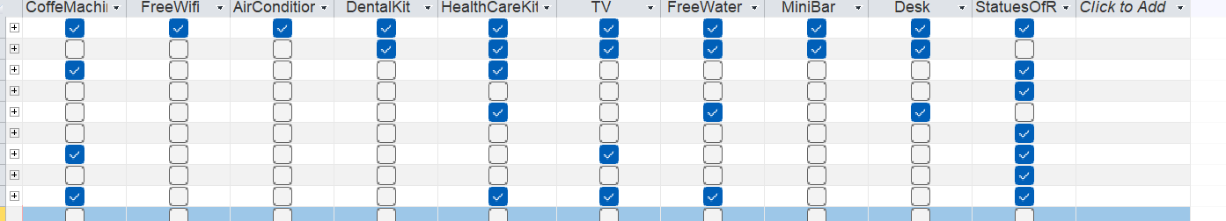

In the database status of the room is still unticked Therefore test passed

Test passed

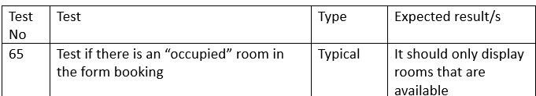

Before

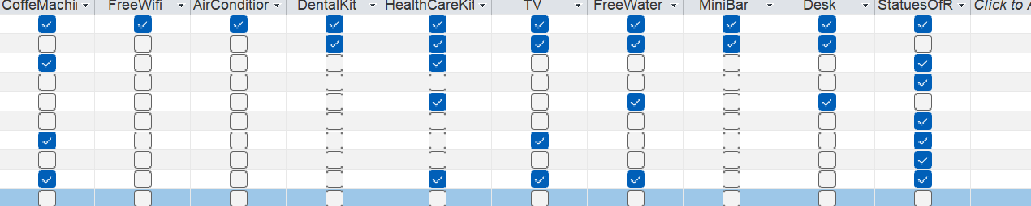

ROOM 2 AND 5 ARE “OCCIPIED”

AFTER

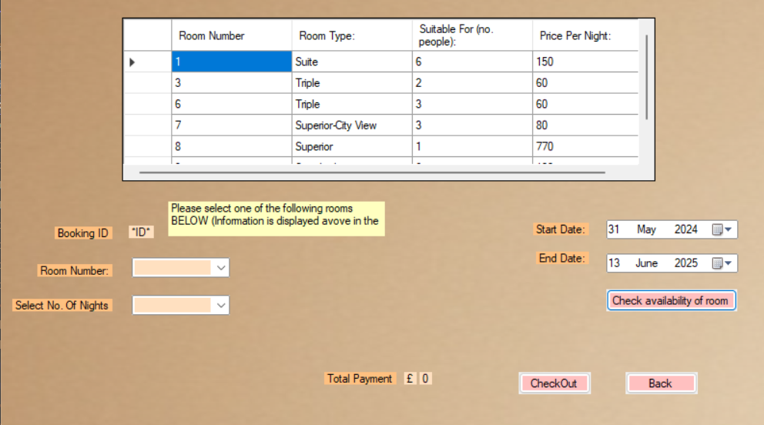

I tried a date when all rooms are available and ROOM 2 AND 5 ARE NOT SHOWING

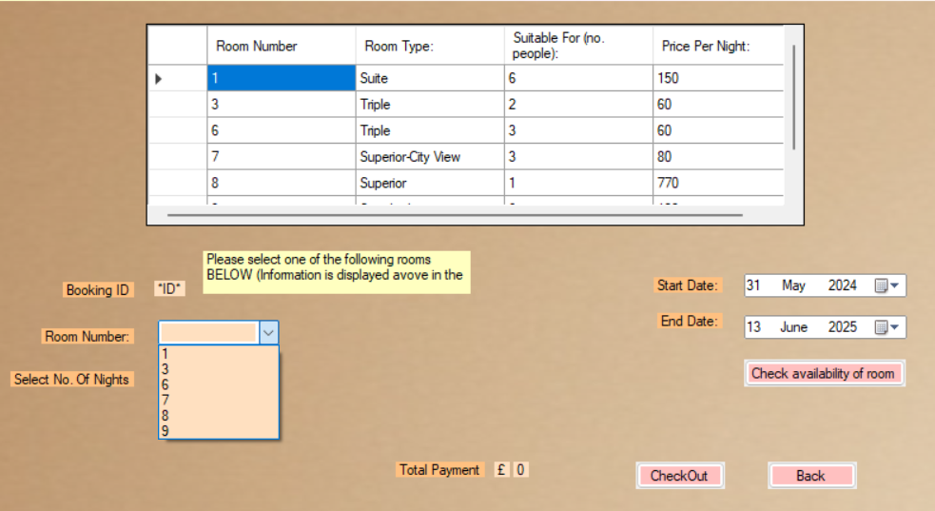

Same with the combo box. Therefore, test passed.

Test passed.

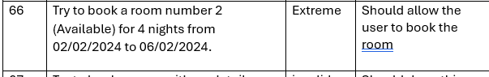

Before

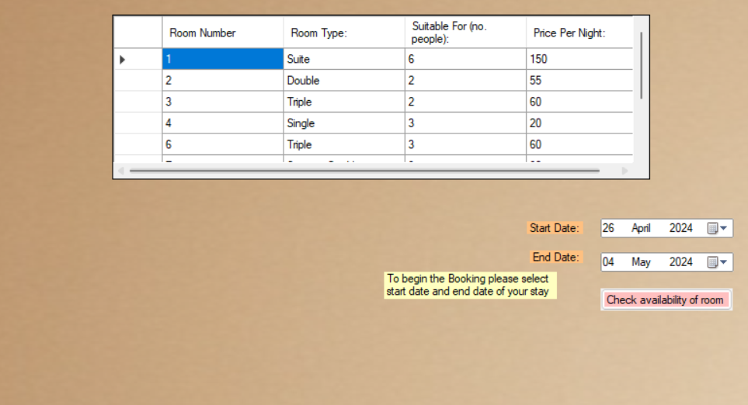

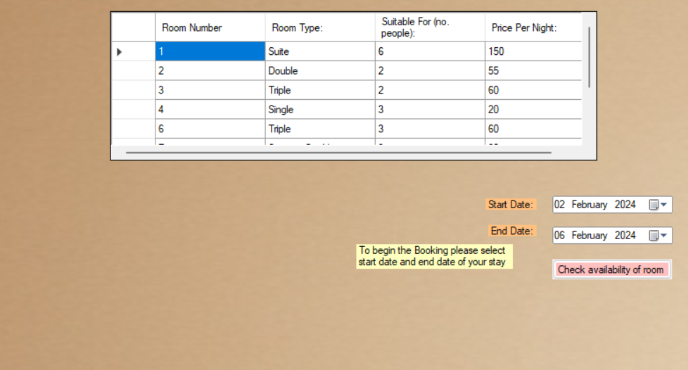

After

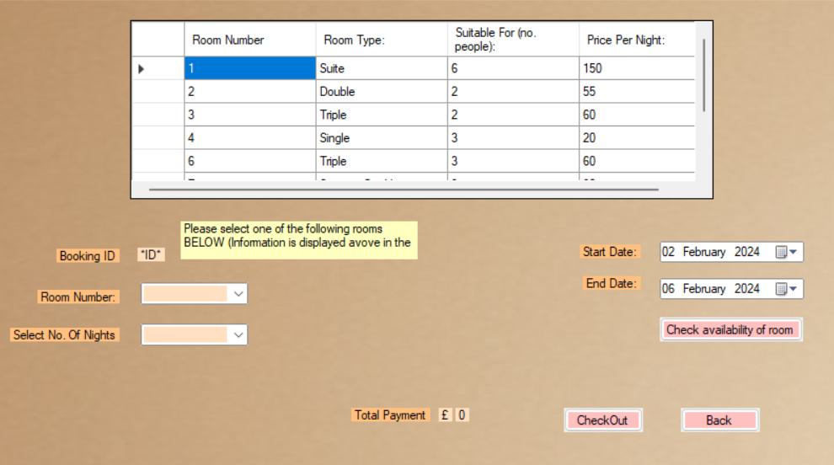

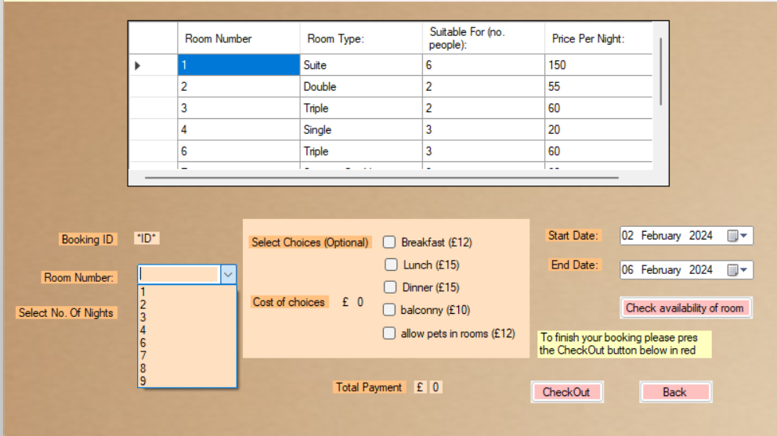

Room 2 is showing therefore test passed.

Test passed.

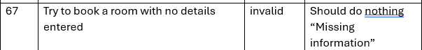

Before



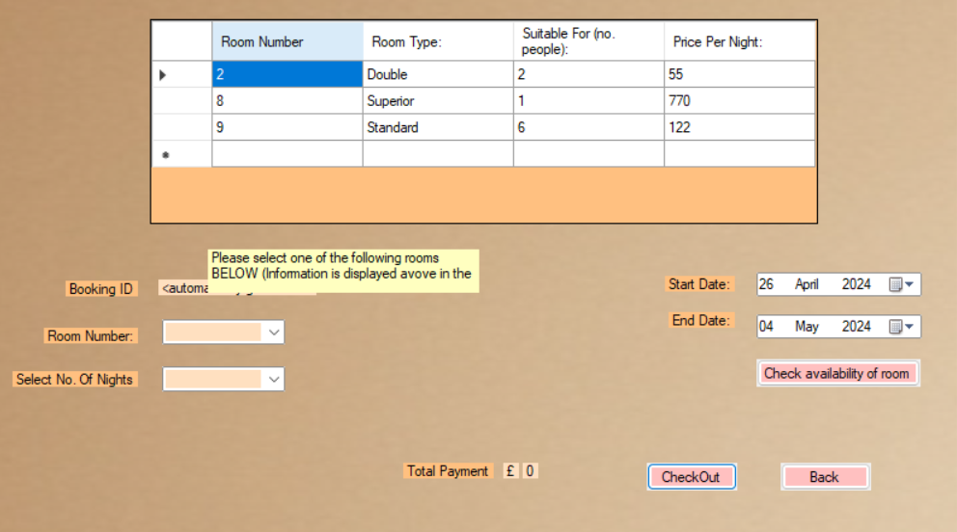

After

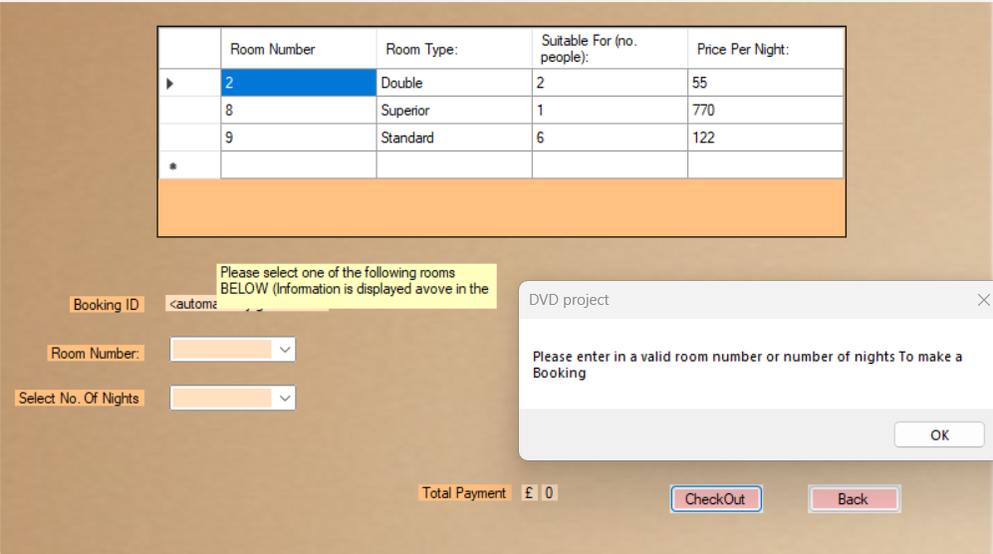



Before

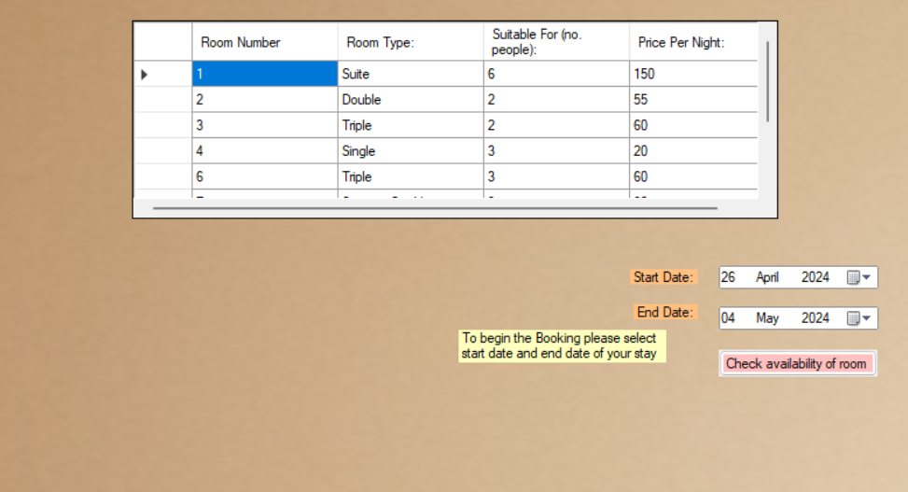

After

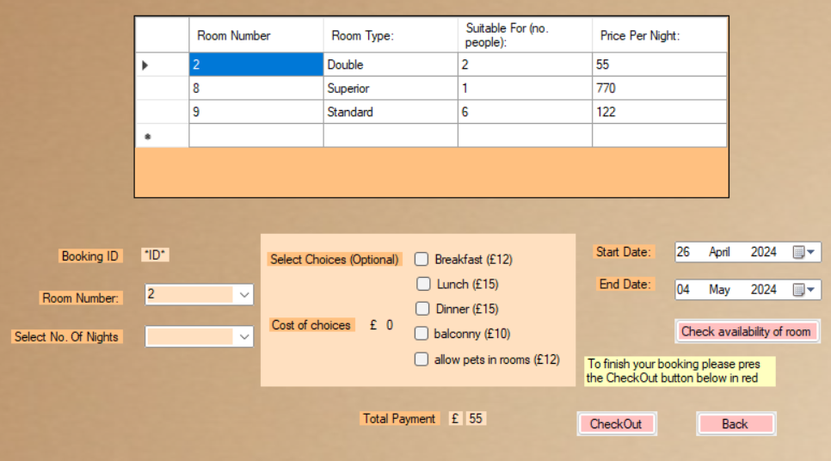

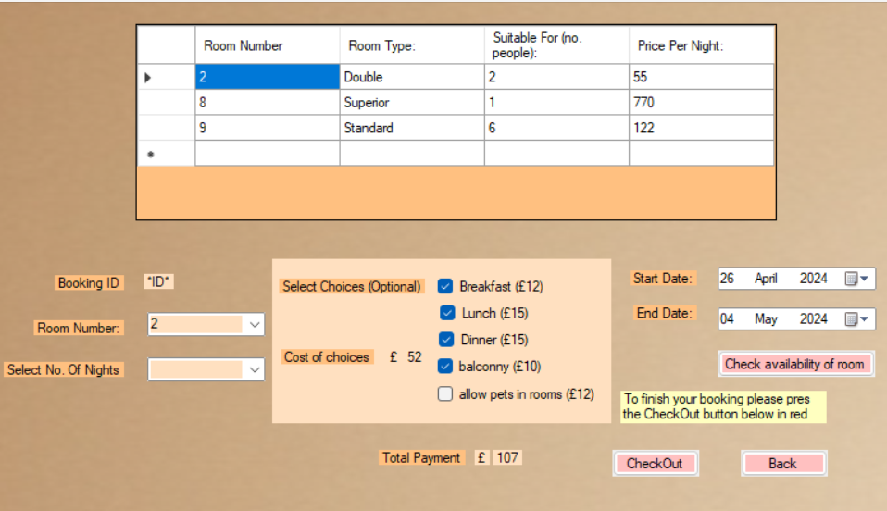

55 + 52 = 107 therefore test passed

Test passed

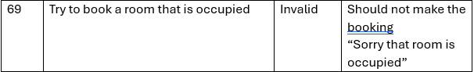

Before

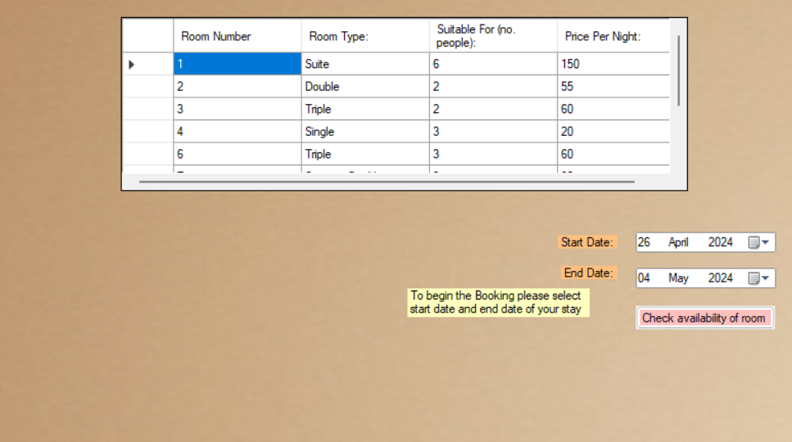

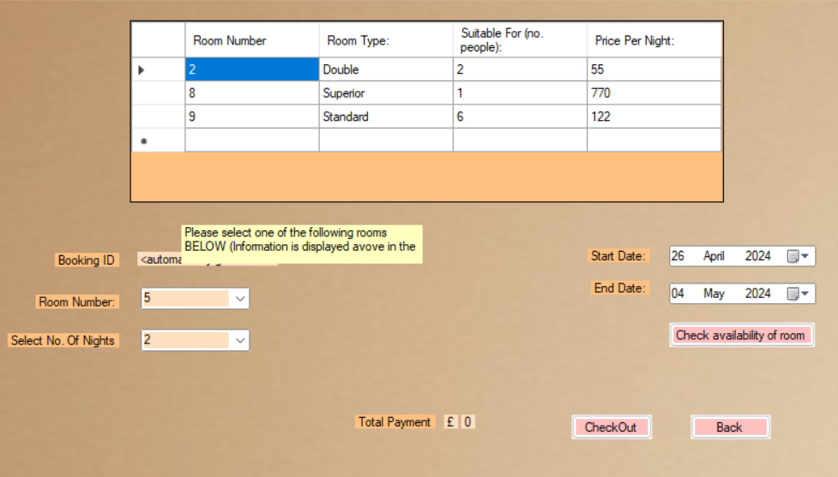

After

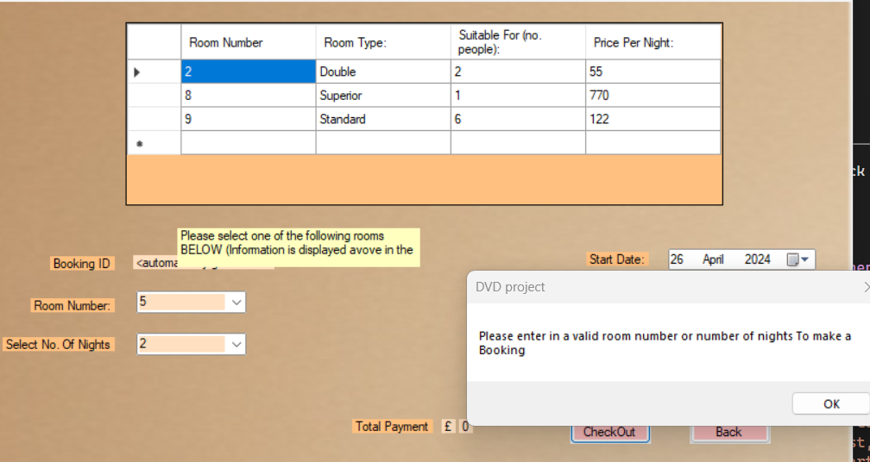

Test passed

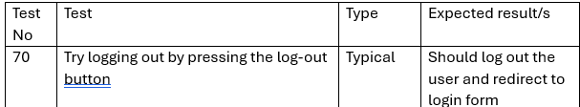

Before

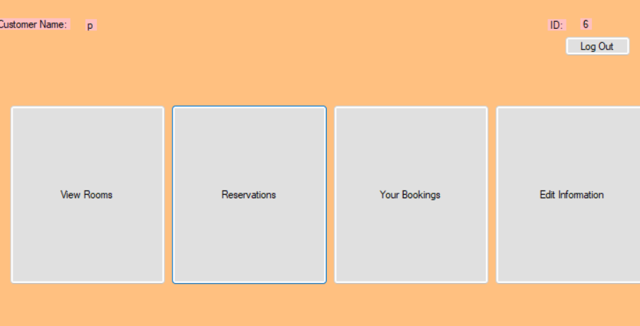

After

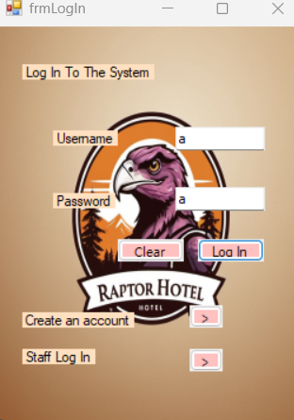

Test passed

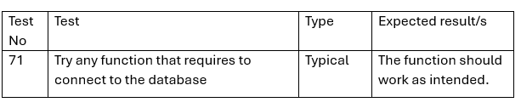

Before

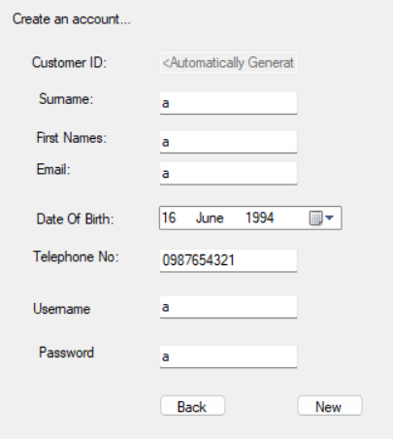

After

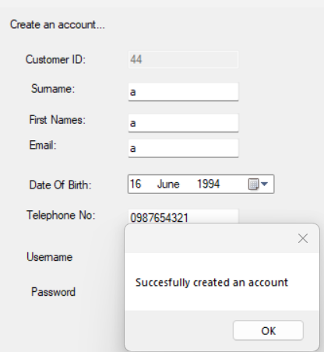



Added to the database therefore it works

Test passed

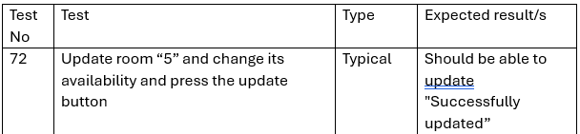

Before

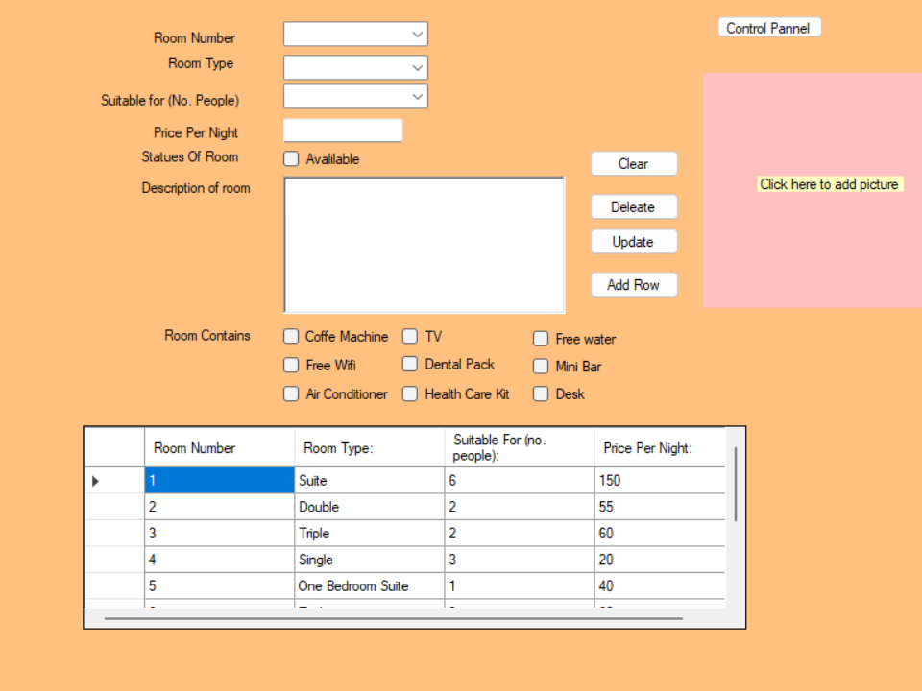

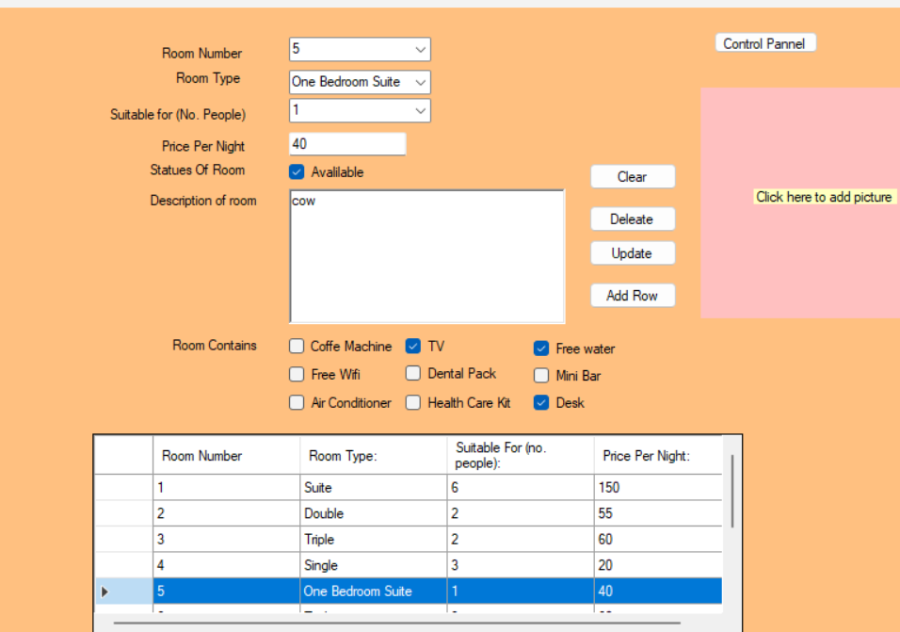

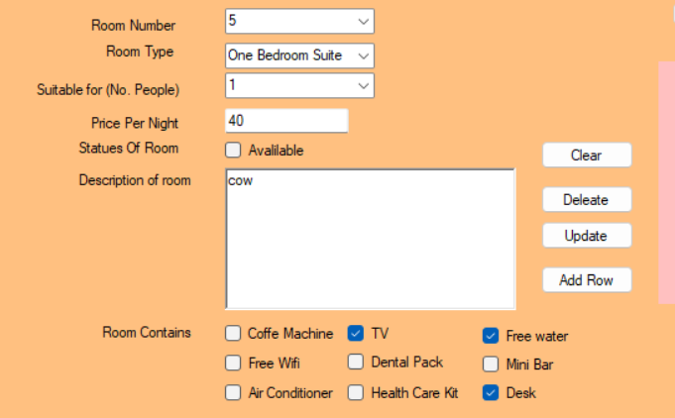

After

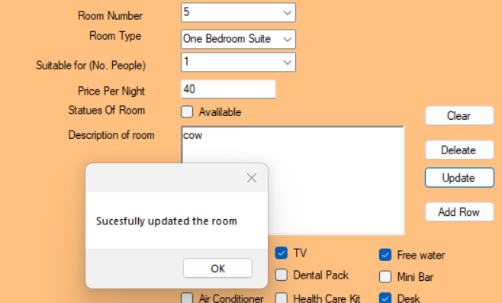

Test passed

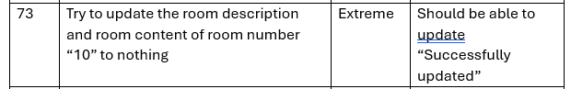

Before



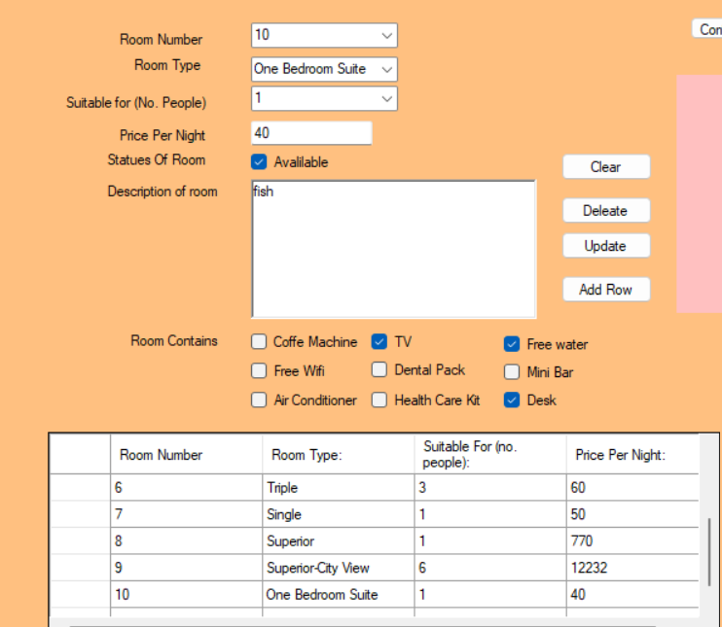

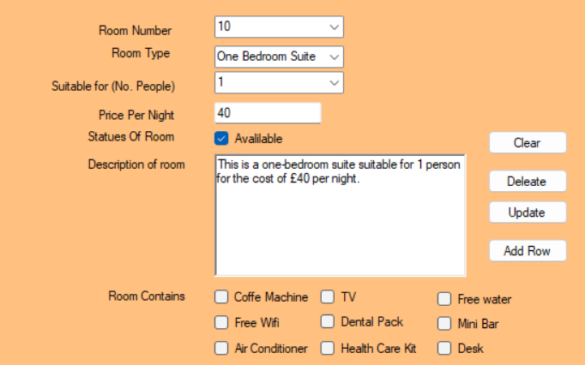

After

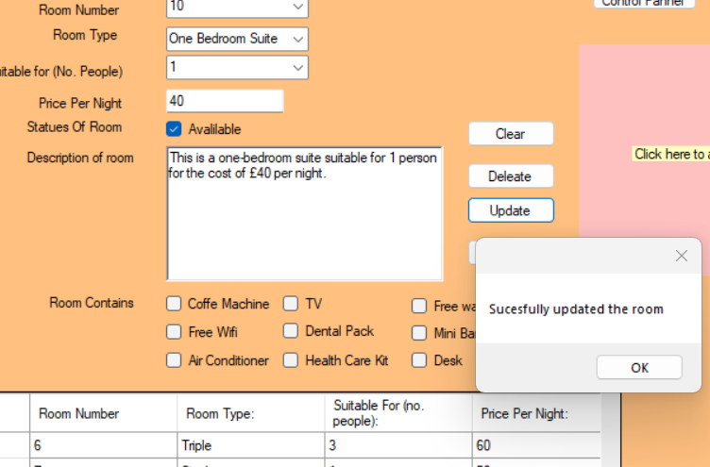



Test passed

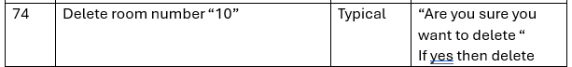

Before



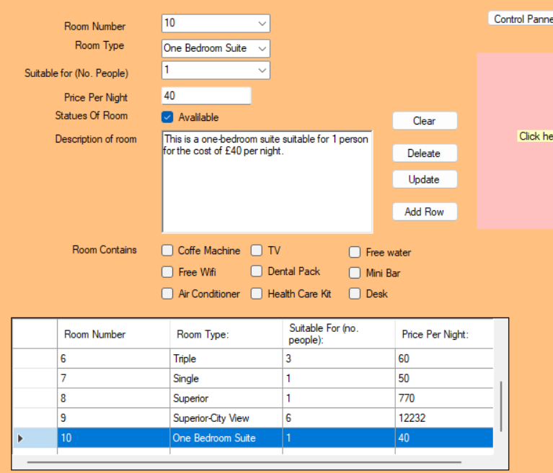

After

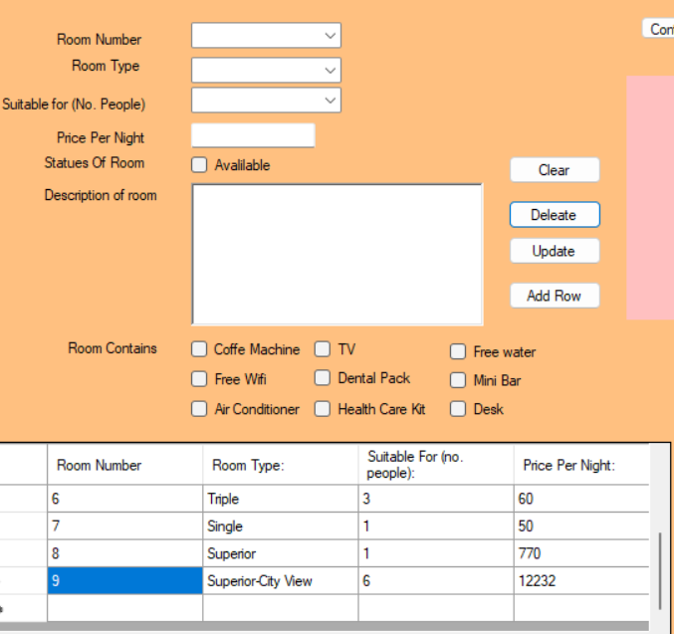



Test passed



Before



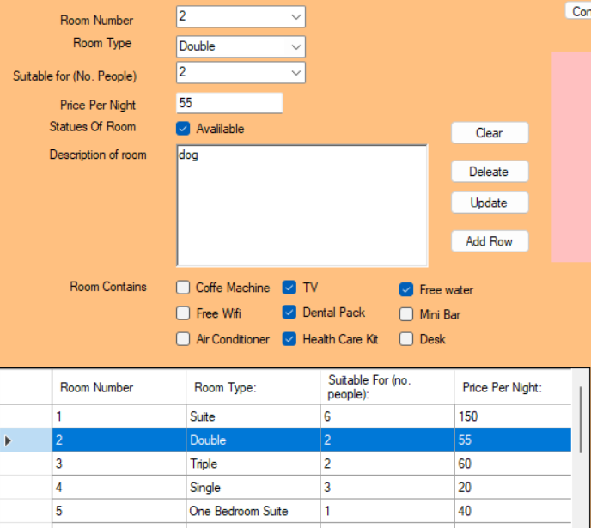

After

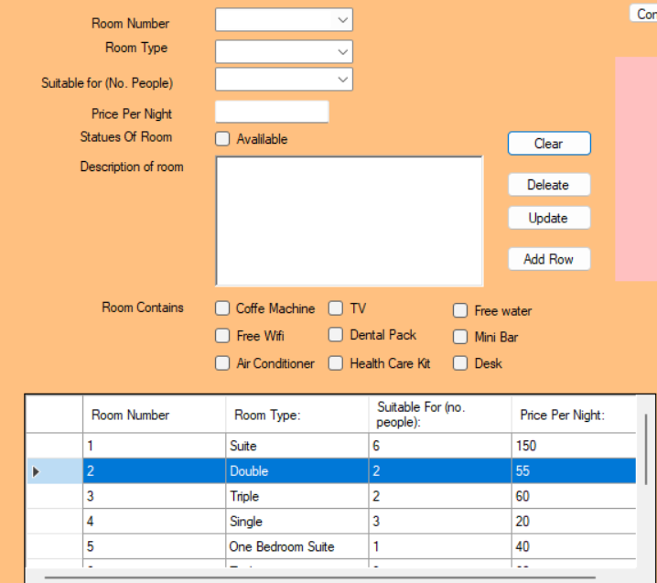

Test passed

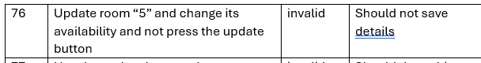

Before



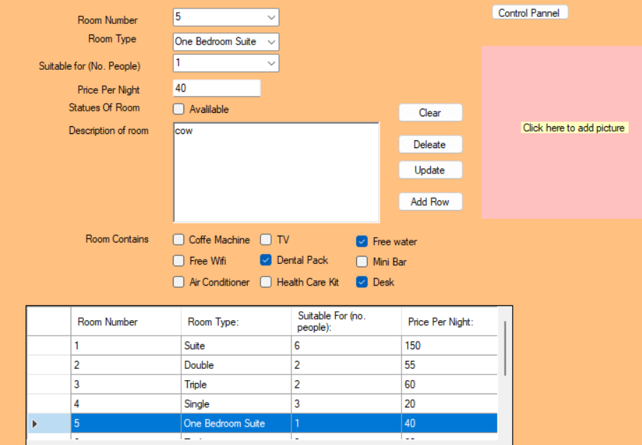

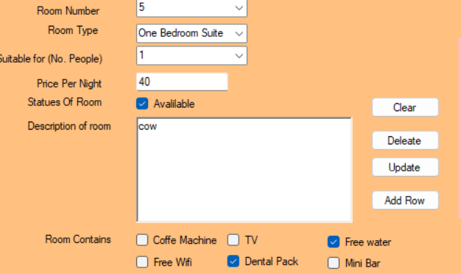

After





Statues of the room is still unticked therefore test passed

Test passed

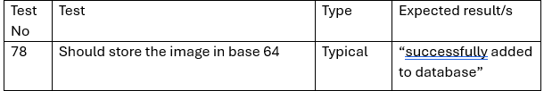

Before



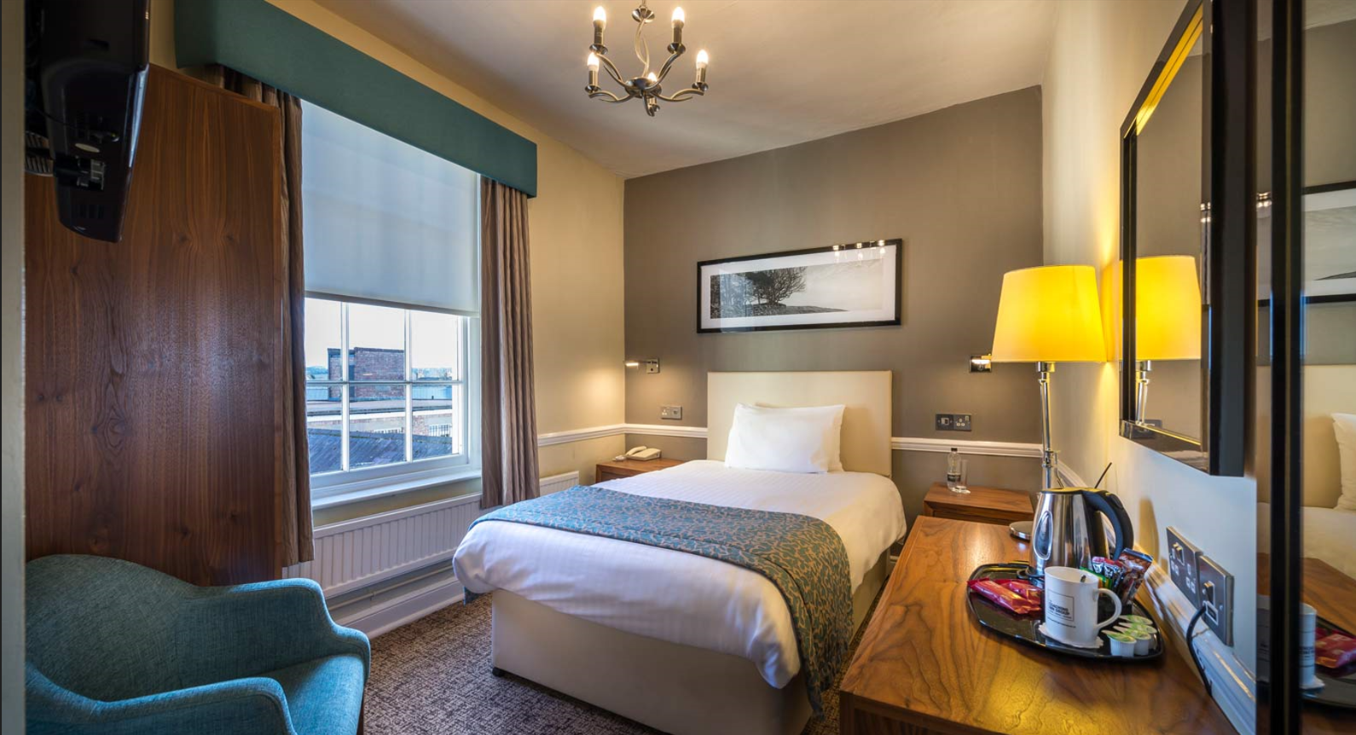

After

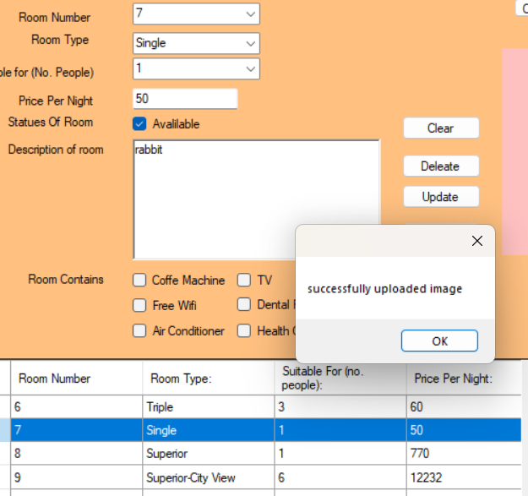



Stores in base 64 therefore test pass

Test pass

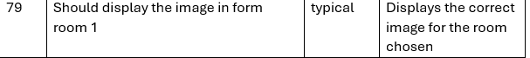

Before

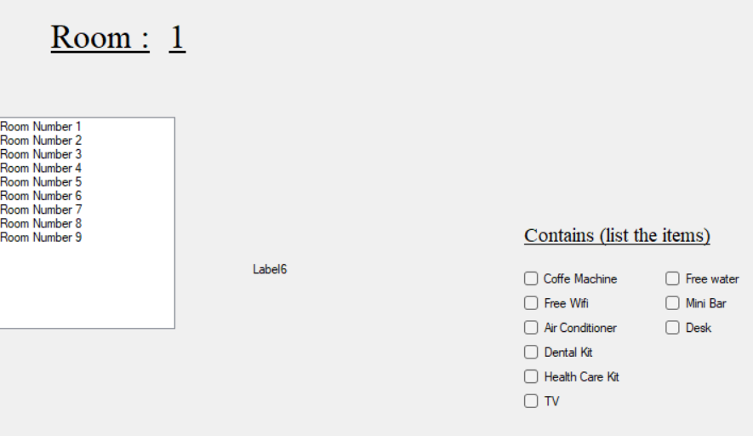

After

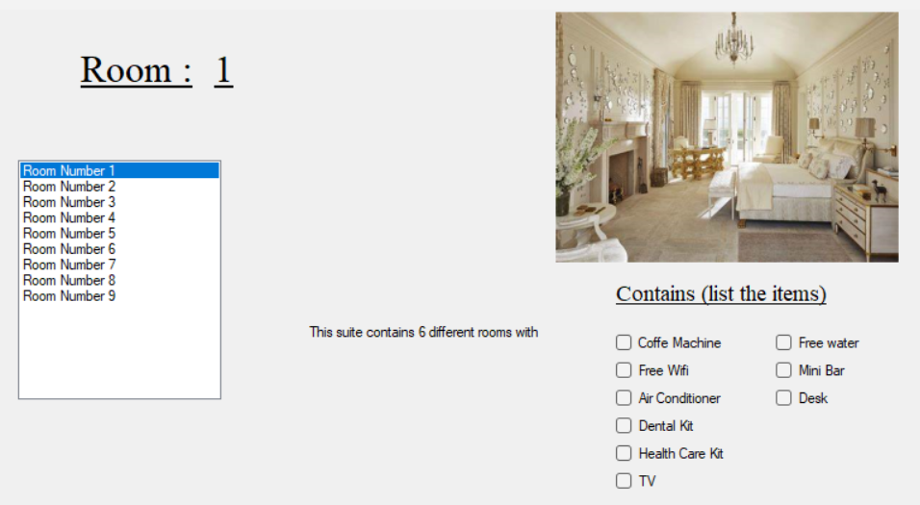

Test passed

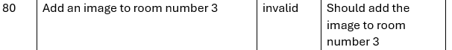

Before



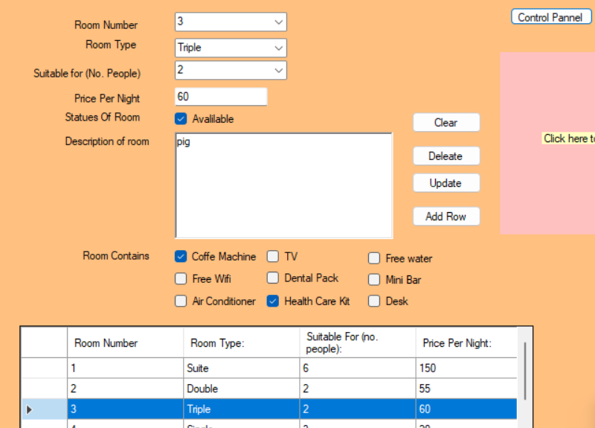



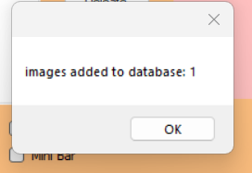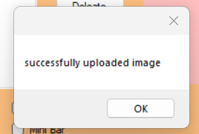

Displaying image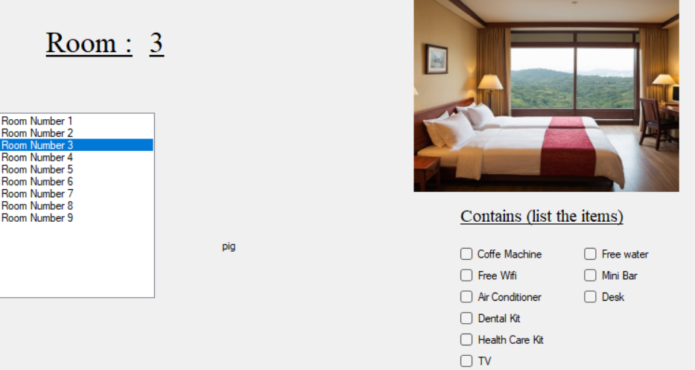

As the image is displayed and added therefore test passed

Test passed